

Requirement & Design Specification
LAB Asset Management (LAM)
Version: 1.0

– Hanoi, August 2026 –

Record of Changes
Version | Date | A*  M, D | In charge | Change Description
V1.1 | 15/8 | A | Nguyễn Minh Anh | Add System actors (Mentor, student, admin, labmanager)
V1.1 | 15/8 | A | Nguyễn Minh Anh | Add Use Case diagram of mentor and student
V1.1 | 15/8 | A | Nguyễn Minh Anh | Add Use Case diagram of admin and lab manager
V1.1 | 15/8 | A | Nguyễn Minh Anh | Add 2.3 Screen Authorization
V1,1 | 15/8 | A | Từ Minh Đức | Add Use Case Description
V1.1 | 15/8 | A | Lương Anh Minh | Add Context Diagram
V1.2 | 17/8 | M | Nguyễn Minh Anh | Change Feature Lab Usage Request to Manage Intern List
V1.2 | 17/8 | M | Nguyễn Minh Anh | Change actor from Student to Intern
V1.2 | 17/8 | M | Nguyễn Minh Anh | Fix Screen Authorization after change Usecase
V1.2 | 17/8 | A | Nguyễn Minh Anh | Add 2.4 Non-UI Functions
V1.2 | 17/8 | A | Nguyễn Minh Anh | Add 2.2 Screen Descriptions
V1.2 | 17/8 | A | Nguyễn Minh Anh | Add Requirement Specifications for Manage Intern List (add,view,list,edit)
V1.2 | 17/8 | A | Từ Minh Đức | Add Requirement Specifications for Manage Responsibilities
V1.2 | 17/8 | A | Trần Bình Minh | Add Requirement Specifications for Manage Users
V1.2 | 17/8 | A | Lương Anh Minh | Add Requirement Specifications for Authentication
V1.2 | 17/8 | A | Lương Anh Minh | Add Requirement Specifications for Manage Asset Usage
V1.2 | 17/8 | A | Lương Anh Minh | Add Requirement Specifications for Manage Asset Disposal
V1.2 | 19/8 | A | Từ Minh Đức | Add Requirement Specifications for Manage Dashboard
*A - Added M - Modified D - Deleted

Contents
Record of Changes 2
I. Overview 5
1. User Requirements 5
1.1 Actor 5
1.2 Use Cases 6
1.3 Context Diagram. 11
1.4 Swimlane Diagram. 11
2. Overall Functionalities 11
2.1 Screens Flow 11
2.2 Screen Descriptions 13
2.3 Screen Authorization 16
2.4 Non-UI Functions 19
3. System High Level Design 20
3.1 Database Design 20
3.2 Code Packages 20
II. Requirement Specifications 22
1. Manage Intern List 22
1.1 View Intern 22
1.2 List Intern 23
1.3 Add Intern 23
1.4 Edit Intern List 25
2. Manage Users 26
2.1 List Users 26
2.2 View User 27
2.3 Add User 28
2.4 Edit User 30
3. Manage Asset 31
3.1 View Asset 31
3.2 List Asset 32
3.3 Add Asset 32
3.4 Edit Asset 33
4. Manage Asset Usage 33
4.1 View Asset Usage 33
4.2 List Asset Usage 34
4.3 Borrow / Declare Asset Usage 35
4.4 Return Asset 36
5. Manage Asset Inspections and Inventories 36
5.1 View Asset Inspection and Inventory 36
5.2 List Asset Inspection and Inventory 37
5.3 Add Asset Inspection and Inventory 38
5.4 Edit Asset Inspection and Inventory 40
6. Manage Asset Incidents 41
6.1 View Asset Incident 41
6.2 List Asset Incident 42
6.3 Add Asset Incident 42
6.4 Edit Asset Incident 43
7. Manage Responsibilities 43
7.1 View Responsibility 43
7.2 List Responsibility 44
7.3 Add Responsibility 45
7.4 Edit Responsibility 47
8. Manage Asset Maintenance 48
8.1 View Asset Maintenance 48
8.2 List Asset Maintenance 48
8.3 Add Asset Maintenance 49
8.4 Edit Asset Maintenance 49
9. Manage Asset Disposal 50
9.1 View Asset Disposal 50
9.2 List Asset Disposal 50
9.3 Add Asset Disposal 51
9.4 Edit Asset Disposal 52
10. Manage Dashboard 53
10.1 View Dashboard 53
11. Authentication 53
11.1 Login with Google 53
11.2 Login with Internal Account 54
11.3 Request Password Reset 55
11.4 Review Password Reset Request 55
11.5 Issue Temporary Password 56
11.6 Change Password 57
11.7 Logout 57
III. Design Specifications 58
1. <<Feature Name>> 58
1.1 <<SubFeature Name>> 58
1.2 System Access 59
IV. Appendix 62
1. Assumptions & Dependencies 62
2. Limitations & Exclusions 62
3. Business Rules 62
4. .. 62

I. Overview

1. User Requirements

1.1 Actor
# | Actor | Description
1 | Admin | Manages user accounts, roles, permissions, and overall system configuration.
2 | Lab Manager | Manages assets, approvals, inventory, transfers, and reports.
3 | Mentor | Requests and uses LAB equipment for teaching or academic activities and reports incidents when needed.
4 | Intern | Requests and uses LAB equipment for learning or projects, returns assets, and reports incidents.

1.2 Use Cases

1.2.1. Intern and mentor Use case Diagram
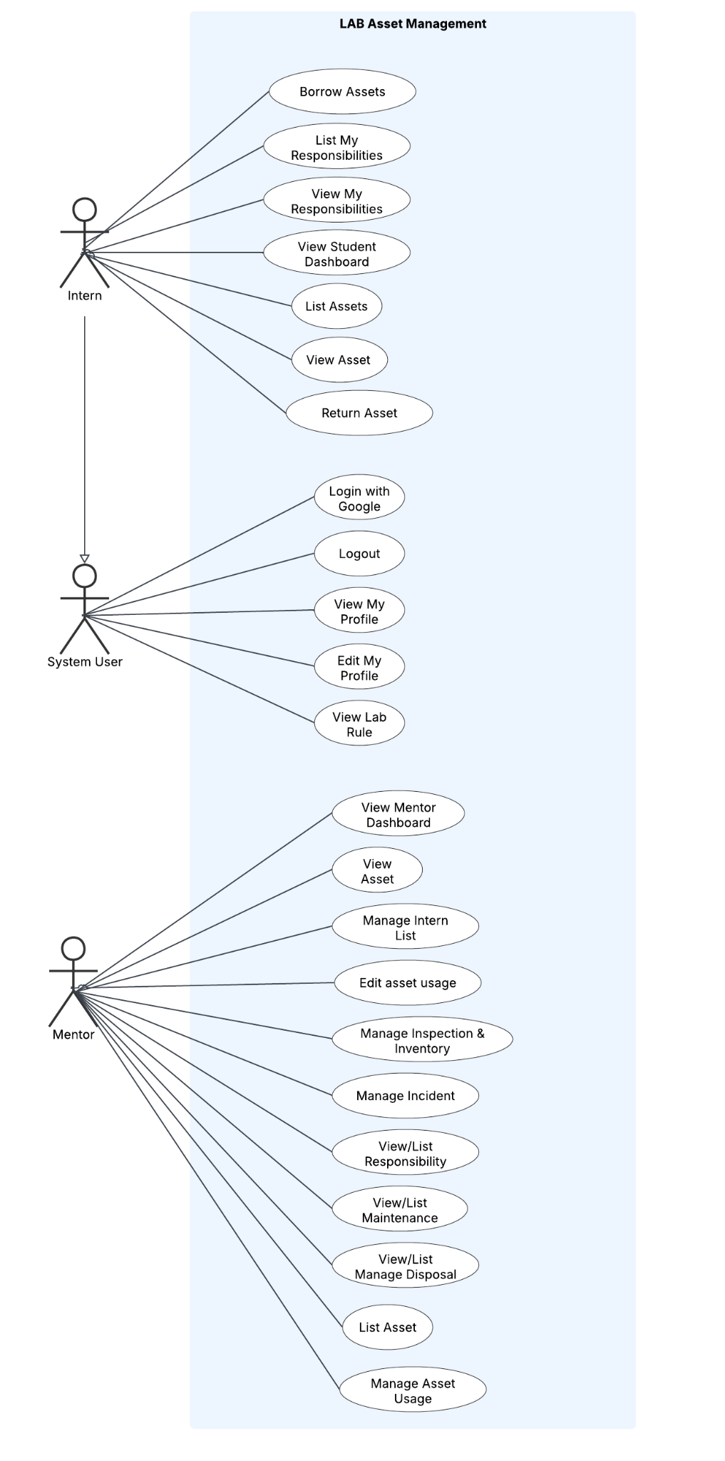

1.2.2. Lab manager and Admin Use case Diagram
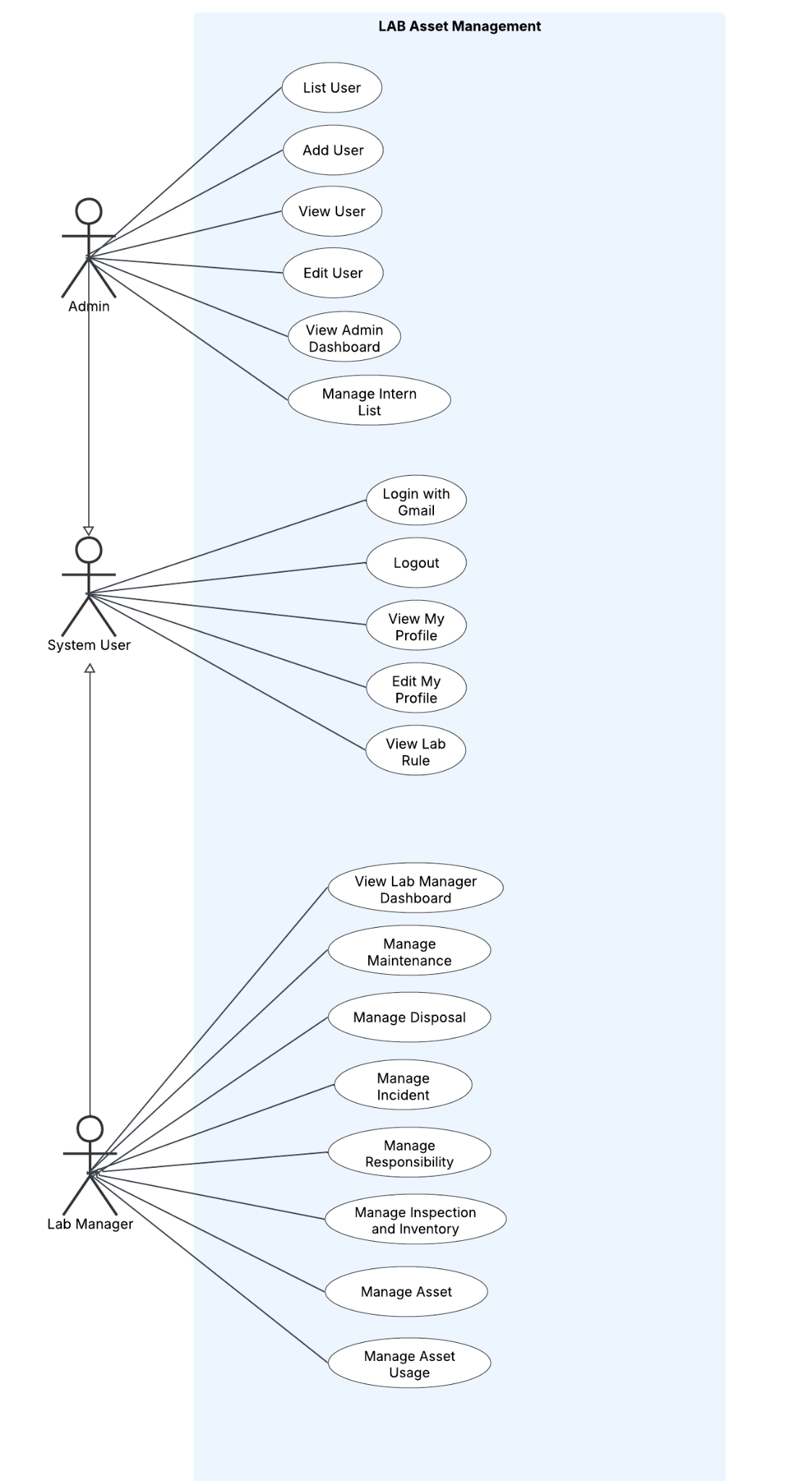

b. Descriptions
ID | Feature | Use Case | Use Case Description
FE-01 | Manage User | View User | View user details, role, email, student information, and account status.
 |  | List Users | View, search, and filter users in the system.
 |  | Add User | Create a new user account and assign an appropriate role.
 |  | Edit User | Update user role, or account status.
FE-02 | Manage Asset | View Asset | View asset details, category, quantity, condition, status, storage location, and assigned seat if applicable.
 |  | List Asset | View, search, and filter LAB equipment, facilities, tools, and components.
 |  | Add Asset | Register a new asset, equipment item, facility, tool, or component in the LAB.
 |  | Edit Asset | Update asset information, quantity, condition, status, storage location, or seat assignment.
FE-03 | Manage Intern List | View Intern List | View the details of an intern list, including the mentor, group, semester, weekly lab schedule, students, and approval status.
 |  | List Intern List | View, search, and filter intern lists by keyword, mentor, group, semester, and status.
 |  | Add Intern List | Create a new intern list by entering the group, semester, weekly lab slots, and student information manually or by importing an Excel file.
 |  | Edit Intern List | Update the group, weekly lab slots, and student information of a pending intern list before it is approved or rejected.
FE-04 | Manage Asset Usage (Mượn đồ) | View Asset Usage | View the student, assigned seat, borrowed or used asset, usage time, return information, and current status.
 |  | List Asset Usage | View and search asset borrowing and usage history by student, seat, or asset.
 |  | Add Asset Usage | Record an asset borrowing or usage transaction for an approved internship student.
 |  | Edit Asset Usage | Update return information, asset condition after use, usage status, or related notes.
FE-05 | Manage Asset Inspections and Inventories (Kiểm kê ) | View Inspection and Inventory | View inspection or inventory details, inspected seat, related assets, quantities, conditions, and results.
 |  | List Inspection and Inventory | View and search inspection and inventory records by date, seat, student, or status.
 |  | Add Inspection and Inventory | Create a new inspection or inventory record for assets at a selected seat or LAB area.
 |  | Edit Inspection and Inventory | Update actual quantity, asset condition, missing assets, discrepancies, and inspection results.
FE-06 | Manage Asset Incidents (Hỏng hóc) | View Incident | View incident details, related asset, seat, student, reporter, description, severity, and status.
 |  | List Incidents | View and search reported asset incidents.
 |  | Add Incident | Report asset damage, loss, missing quantity, malfunction, or another abnormal condition.
 |  | Edit Incident | Update investigation details, related student or seat, handling result, severity, and incident status.
FE-07 | Manage Responsibilities (Quản lý trách nghiệm) | View Responsibility | View the related incident, student, seat, asset usage history, evidence, responsibility result, and handling decision.
 |  | List Responsibility | View and search responsibility records created from asset incidents.
 |  | Add Responsibility | Create a responsibility record after investigating an incident and identifying the related student and asset usage.
 |  | Edit Responsibility | Update investigation conclusions, responsibility decision, compensation, penalty, replacement, or resolution status.
FE-08 | Manage Asset Maintenance (Bảo trì hỏng hóc) | View Maintenance Record | View maintenance details, related asset, incident, approval status, repair progress, result, and current asset status.
 |  | List Maintenance Records | View, search, and filter asset maintenance and repair records by asset, status, or request information.
 |  | Add Maintenance Record | Create a maintenance or repair request for an asset that is damaged, malfunctioning, or requires corrective action.
 |  | Edit Maintenance Record | Update repair progress, repair result, related notes, and asset status during or after maintenance.
FE-09 | Manage Asset Disposal (Tiêu hủy ) | View Disposal Record | View disposal details, including related asset, reason, asset condition, request information, approval status, and disposal result.
 |  | List Disposal Records | View and search assets pending disposal or already disposed of.
 |  | Add Disposal Record | Create a disposal request for an asset that can no longer be safely or effectively used.
 |  | Edit Disposal Record | Update the disposal reason, related information, completion details, and disposal status.
FE-10 | Manage Dashboard | View Dashboard | View summarized information about assets, seats, internship students, asset usage, inspections, incidents, maintenance, and disposal.
FE-11 | Manage Intern Equipment Allocation | Add Intern Equipment Allocation | Allows Mentor to create an equipment allocation for an intern and submit it to the Lab Manager for approval.
 |  | List Intern Equipment Allocation | Displays the list of intern equipment allocations and their approval status.
 |  | View Intern Equipment Allocation | Displays detailed information of an intern equipment allocation for review and approval.
 |  | Edit Intern Equipment Allocation | Allows Mentor to update an intern equipment allocation before submitting it for approval.
AU-01 | Authentication | Login with Google | Sign in as an Intern using an authorized FPT Google account already provisioned locally.
 |  | Request Password Reset | Allow Mentor or Lab Manager to submit an internal-account password reset request for Admin review.
 |  | Review Password Reset Request | Allow Admin to approve or reject a pending password reset request.
 |  | Issue Temporary Password | Allow Admin to issue a time-limited temporary password for an approved reset request.
 |  | Change Password | Allow an internal user to change their password; a temporary password requires change before normal access.
 |  | Logout | End the authenticated session and return to Login.

1.3 Context Diagram.
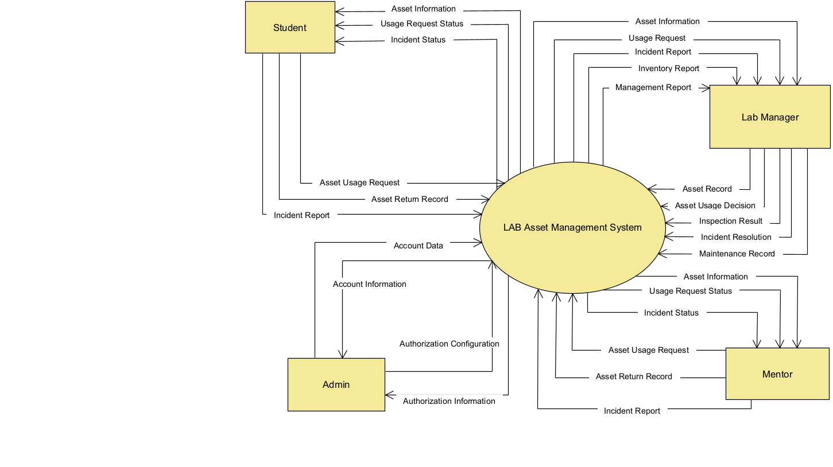

1.4 Swimlane Diagram.

1.4.1 Manage Asset End to End Swimlane Diagram

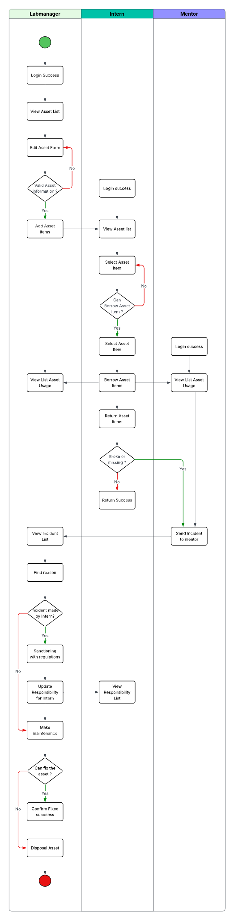

1.4.2 Manage Account and Intern List Swimlane Diagram

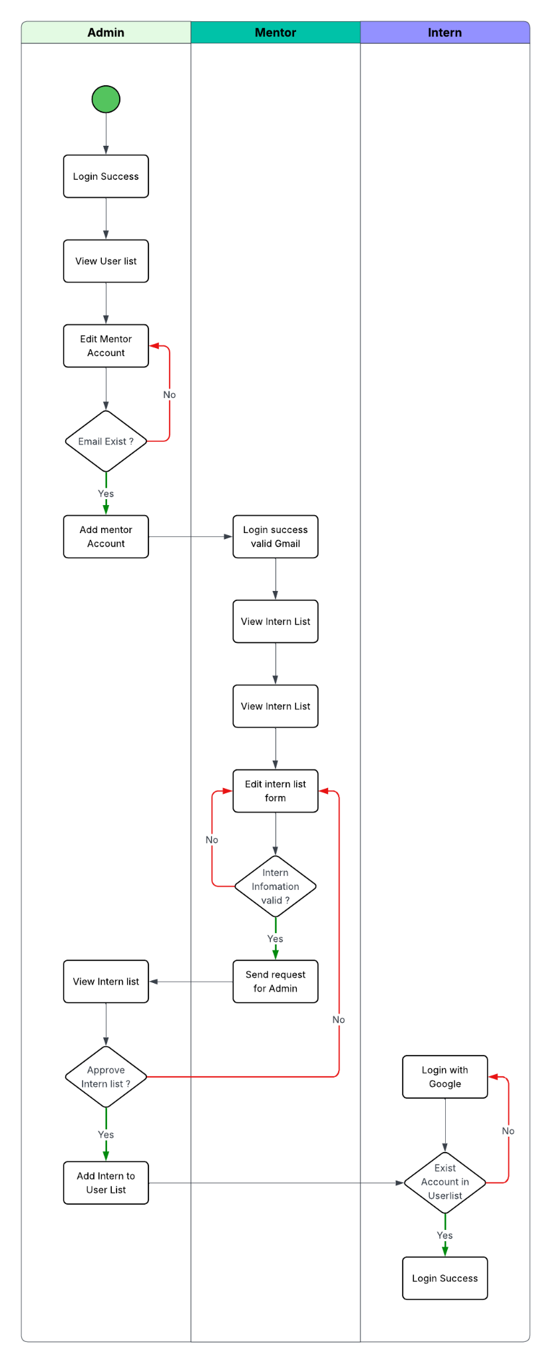

2. Overall Functionalities

2.1 Screens Flow
- Admin screen flow

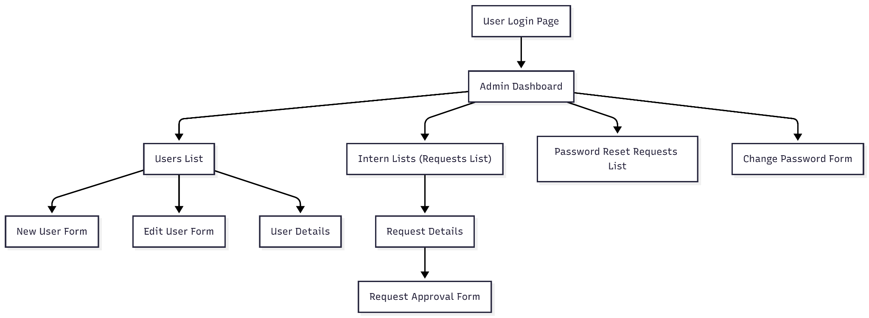

b, Intern screen flow

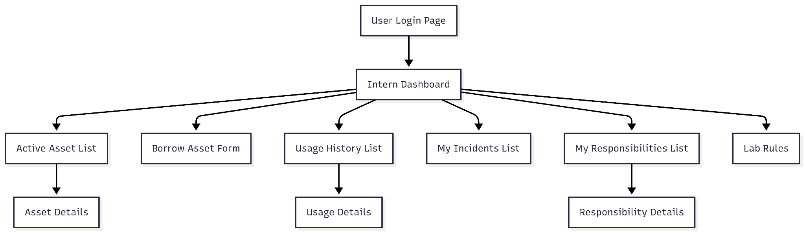

c, Mentor screen flow

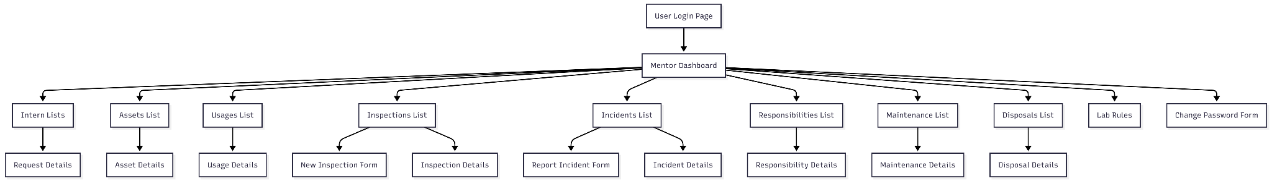

d, Labmanager screen flow

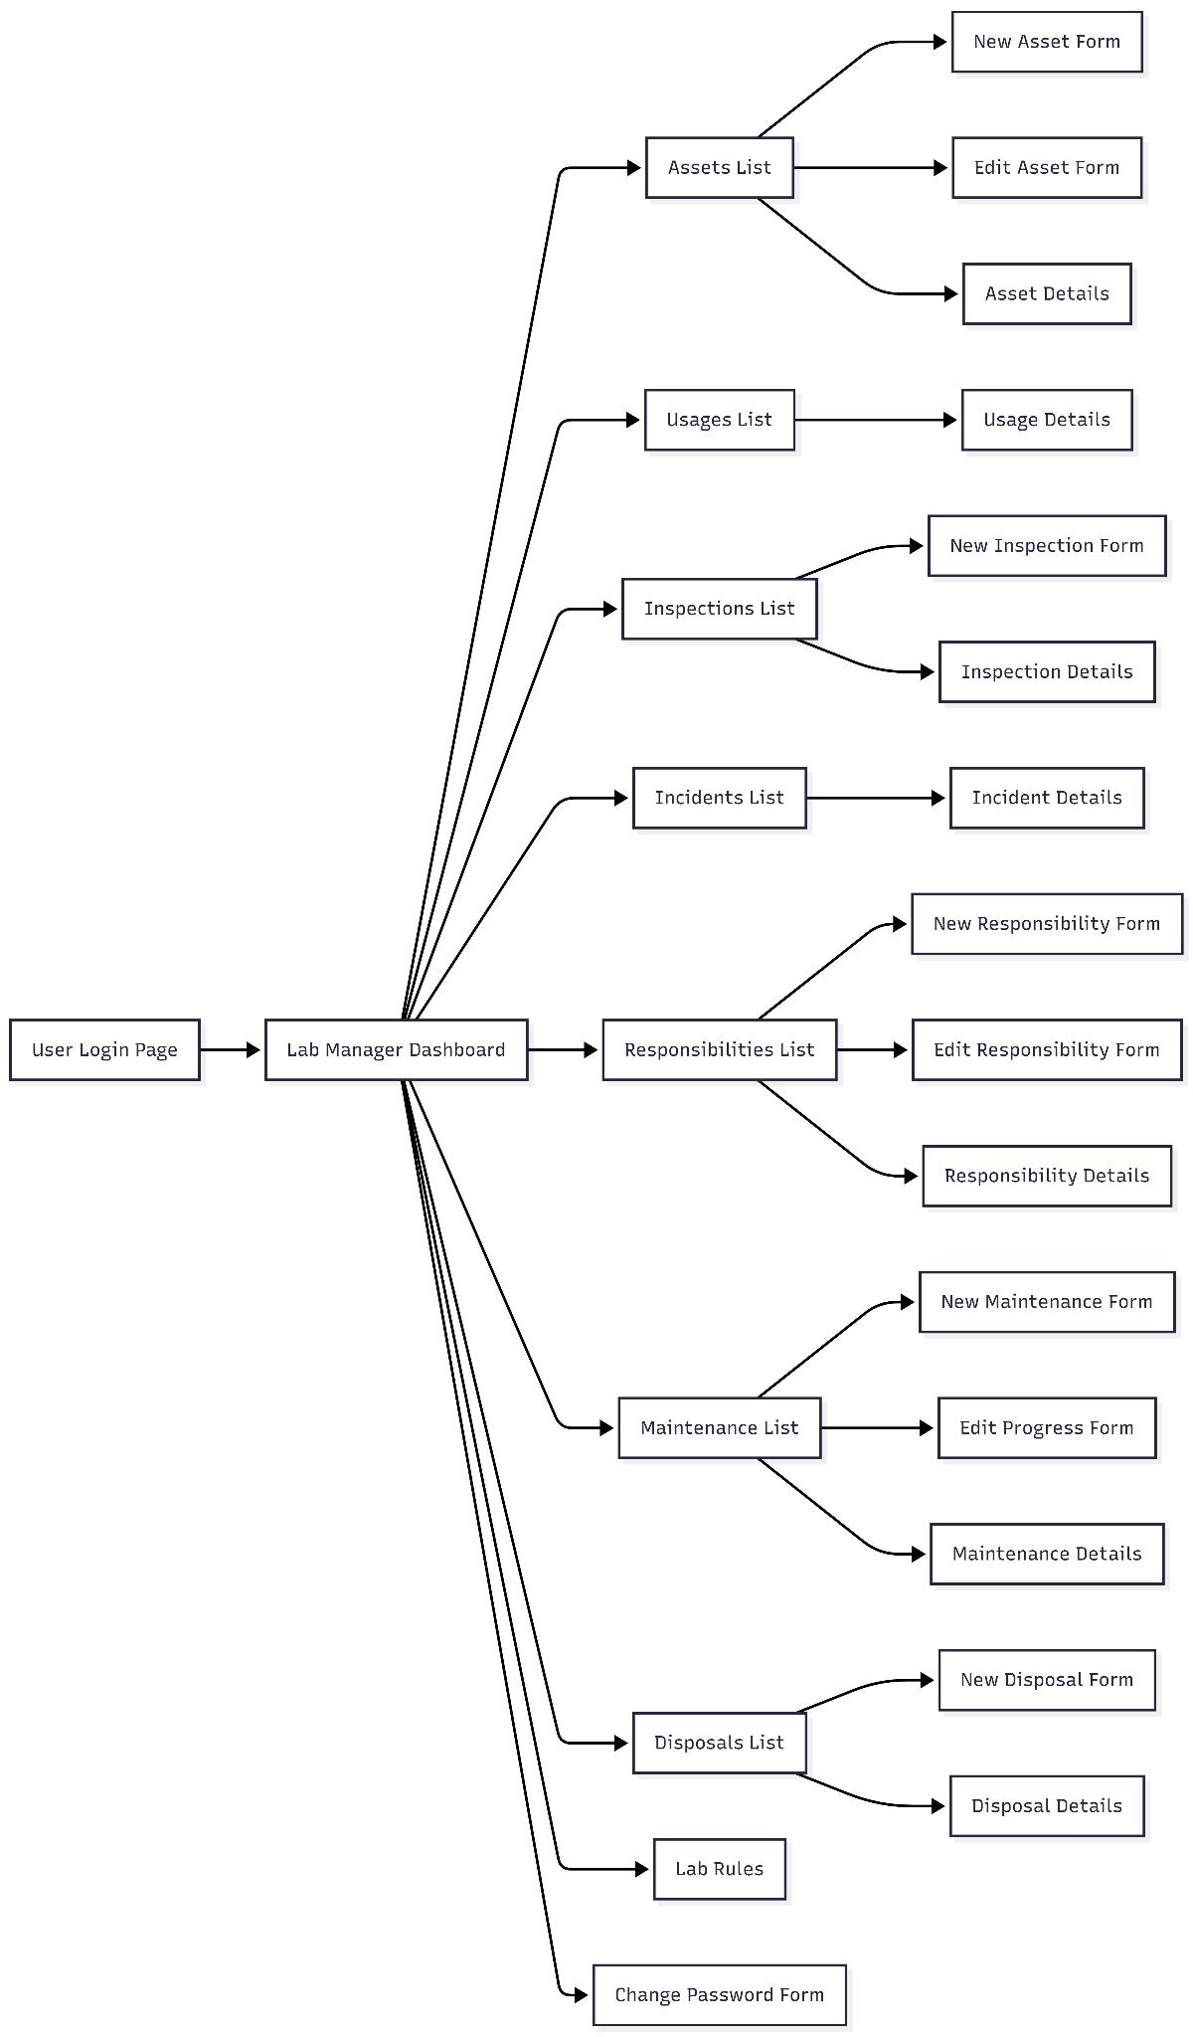

e, Total screen flow

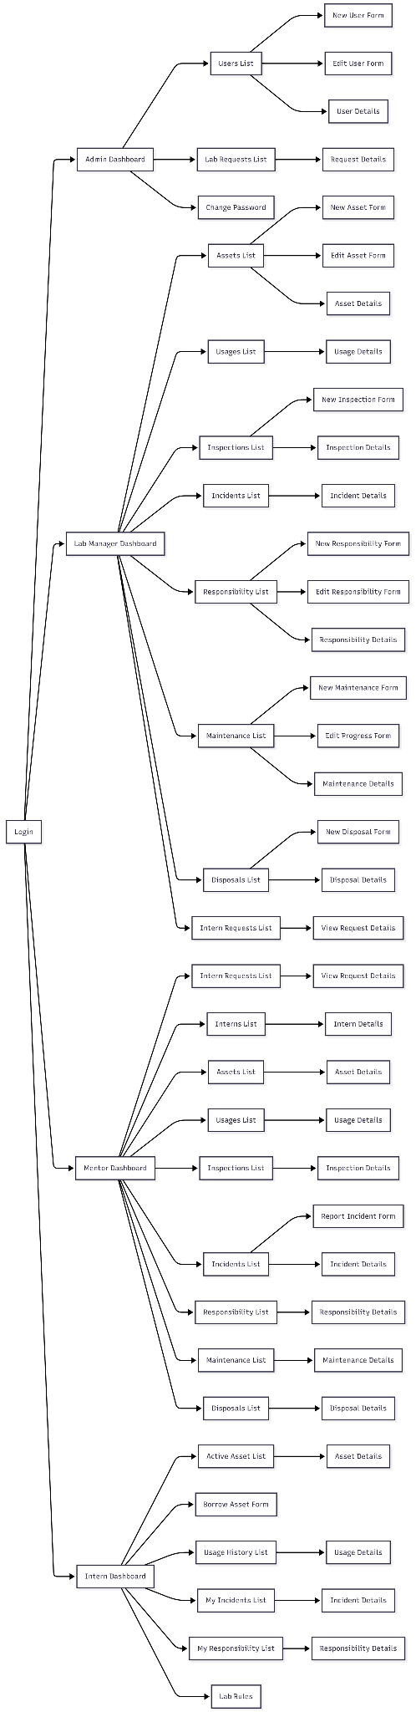

2.2 Screen Descriptions
# | Feature | Screen | Description
1 | FE-01 Manage User | User List | Display and search all user accounts in the system. Admin can filter users by role and account status.
2 | FE-01 Manage User | User Detail | Display user information, email, full name, assigned role, account status, Google account binding, and account creation information.
3 | FE-01 Manage User | Add User | Create a new user account using an authorized email address and assign the Admin, Lab Manager, Mentor, or Intern role.
4 | FE-01 Manage User | Edit User | Update user information, change the assigned role, and activate or deactivate the account.
5 | FE-02 Manage Asset | Asset List | Display and search all laboratory assets. Assets can be filtered by category, borrowability, condition, quantity, and status.
6 | FE-02 Manage Asset | Asset Detail | Display detailed asset information, including asset code, name, type, category, quantity, condition, borrowability, and current status.
7 | FE-02 Manage Asset | Add Asset | Register a new fixed or borrowable asset and enter its identification, category, quantity, condition, and description.
8 | FE-02 Manage Asset | Edit Asset | Update asset information, quantity, category, condition, borrowability, and operational status.
9 | FE-03 Manage Intern List | Mentor Intern List | Display the intern lists submitted by the Mentor by semester, including the number of interns and approval status.
10 | FE-03 Manage Intern List | Mentor Intern List Detail | Display the semester information and all interns contained in a selected list.
11 | FE-03 Manage Intern List | Create Intern List | Create the official intern list for a semester and add participating interns before submitting it to the Admin.
12 | FE-03 Manage Intern List | Edit Intern List | Update semester information or intern membership while the list is still in Pending status.
13 | FE-03 Manage Intern List | Import Intern List | Upload an Excel file containing intern codes, names, emails, and cohort information and validate the imported data.
14 | FE-03 Manage Intern List | Admin Intern List | Display all intern lists submitted by the Mentor and allow the Admin to filter them by semester and approval status.
15 | FE-03 Manage Intern List | Admin Intern List Detail | Display a submitted intern list and allow the Admin to review its semester and membership information.
16 | FE-03 Manage Intern List | Review Intern List | Allow the Admin to approve or reject a pending intern list and provide a rejection reason when necessary.
17 | FE-03 Manage Intern List | Admin Edit Intern List | Allow the Admin to update an intern list in any status. Updating an approved list synchronizes the official semester membership.
18 | FE-04 Manage Asset Usage | Borrow Asset | Allow an approved Intern to select a borrowable asset, enter the requested quantity, borrow date, due date, and submit the borrowing transaction.
19 | FE-04 Manage Asset Usage | My Asset Usage | Display the current Intern's borrowing and return history, including asset, quantity, borrowing date, due date, and usage status.
20 | FE-04 Manage Asset Usage | My Asset Usage Detail | Display the detailed information and current state of one borrowing transaction belonging to the logged-in Intern.
21 | FE-04 Manage Asset Usage | Return Asset | Record the return date, returned quantity, asset condition, and notes for an active borrowing transaction.
22 | FE-04 Manage Asset Usage | All Asset Usage | Allow the Mentor and Lab Manager to search and monitor all asset borrowing and return transactions.
23 | FE-04 Manage Asset Usage | Asset Usage Detail | Display the Intern, asset, borrowed quantity, borrowing period, return information, condition, and status of a transaction.
24 | FE-05 Manage Asset Inspections and Inventories | Inspection and Inventory List | Display and search all laboratory inspection and inventory records by date, creator, type, and status.
25 | FE-05 Manage Asset Inspections and Inventories | Inspection and Inventory Detail | Display the assets checked in an inspection, expected and actual quantities, condition results, missing assets, and discrepancies.
26 | FE-05 Manage Asset Inspections and Inventories | Create Inspection and Inventory | Create an inspection for all laboratory assets or a selected asset group without using seat-based assignment.
27 | FE-05 Manage Asset Inspections and Inventories | Edit Inspection and Inventory | Update actual quantities, conditions, discrepancy notes, missing-asset information, and completion status.
28 | FE-06 Manage Asset Incidents | Incident List | Display and search all reported incidents by asset, reporter, incident type, severity, date, and status.
29 | FE-06 Manage Asset Incidents | Incident Detail | Display the related asset, reporter, actual incident time, description, severity, evidence, handling progress, and current status.
30 | FE-06 Manage Asset Incidents | Report Incident | Allow the Mentor or Intern to report asset damage, loss, shortage, malfunction, overdue return, or another abnormal condition.
31 | FE-06 Manage Asset Incidents | Edit Incident | Update incident information, severity, evidence, related asset, investigation notes, handling result, and status.
32 | FE-06 Manage Asset Incidents | My Incidents | Display only the incidents reported by or related to the logged-in Intern.
33 | FE-06 Manage Asset Incidents | My Incident Detail | Display the description, related asset, submitted evidence, handling progress, and result of an Intern's incident.
34 | FE-07 Manage Responsibilities | Responsibility List | Allow the Mentor and Lab Manager to search responsibility records created from investigated incidents.
35 | FE-07 Manage Responsibilities | Responsibility Detail | Display the incident, responsible Intern, investigation evidence, conclusion, severity, compensation, penalty, and approval status.
36 | FE-07 Manage Responsibilities | Add Responsibility | Allow the Mentor to create a responsibility record after investigating an incident and identifying the responsible Intern.
37 | FE-07 Manage Responsibilities | Edit Responsibility | Update investigation conclusions, responsibility decisions, compensation, penalties, replacement information, and resolution status.
38 | FE-07 Manage Responsibilities | Review Critical Responsibility | Allow the Lab Manager to approve or reject High or Critical responsibility decisions submitted by the Mentor.
39 | FE-07 Manage Responsibilities | My Responsibilities | Display all responsibility records assigned to the logged-in Intern.
40 | FE-07 Manage Responsibilities | My Responsibility Detail | Display the related incident, investigation conclusion, compensation, penalty, approval decision, and completion status.
41 | FE-08 Manage Asset Maintenance | Maintenance List | Display and search all maintenance and repair records by asset, requester, maintenance status, and request date.
42 | FE-08 Manage Asset Maintenance | Maintenance Detail | Display the related asset, reported problem, requester, repair notes, assigned technician, costs, dates, and current status.
43 | FE-08 Manage Asset Maintenance | Create Maintenance Request | Allow the Mentor or Lab Manager to create a repair or maintenance request for a damaged or malfunctioning asset.
44 | FE-08 Manage Asset Maintenance | Edit Maintenance Record | Update the maintenance description, technician, repair progress, repair result, cost, dates, notes, and status.
45 | FE-08 Manage Asset Maintenance | Review Maintenance Request | Allow the Lab Manager to approve or reject a submitted maintenance request and record the management decision.
46 | FE-09 Manage Asset Disposal | Disposal List | Display and search all assets pending disposal, cancelled disposal processes, and completed disposal records.
47 | FE-09 Manage Asset Disposal | Disposal Detail | Display the asset, disposal reason, request information, approval status, processing status, and disposal result.
48 | FE-09 Manage Asset Disposal | Create Disposal Process | Allow the Lab Manager to create a disposal process for an entire asset record that is no longer safe or useful.
49 | FE-09 Manage Asset Disposal | Edit Disposal Process | Update the disposal reason and process information, cancel a pending process, or complete disposal when the asset has no active borrowing transaction.
50 | FE-10 Manage Dashboard | Admin Dashboard | Display summarized information about users, roles, account statuses, intern-list approval requests, and system management activities.
51 | FE-10 Manage Dashboard | Lab Manager Dashboard | Display summarized information about assets, usage, inspections, incidents, responsibilities, maintenance, and disposal processes.
52 | FE-10 Manage Dashboard | Mentor Dashboard | Display summarized information about the current intern list, assets, borrowing transactions, incidents, responsibilities, and maintenance requests.
53 | FE-10 Manage Dashboard | Intern Dashboard | Display the Intern's current borrowings, overdue assets, recent incidents, responsibilities, and available actions.
54 | AU-01 Authentication | Login | Allow Admin, Lab Manager, and Mentor to use an internal account; allow a provisioned Intern to use an authorized FPT Google account. Development authentication is available only when explicitly enabled.
55 | AU-01 Authentication | Logout | Terminate the current authenticated session and redirect the user to the Login screen.
56 | AU-01 Authentication | Request Password Reset | Allow Mentor or Lab Manager to submit a password reset request for Admin review.
57 | AU-01 Authentication | Password Reset Administration | Allow Admin to review requests and issue a temporary password only after approval.
58 | AU-01 Authentication | Change Password | Allow Admin, Lab Manager, or Mentor to change the current or temporary password.

2.3 Screen Authorization
Screen | Admin | Lab manager | Mentor | Intern
Google sign-in | ✓ | ✓ | ✓ | ✓
Development sign-in | ✓ | ✓ | ✓ | ✓
Password reset request |  | ✓ | ✓
Review / issue temporary password | ✓
Change password / sign out | ✓ | ✓ | ✓ | ✓
Role dashboard | ✓ | ✓ | ✓ | ✓
View user list / details | ✓
Create / edit / activate / deactivate / delete users | ✓
View intern lists | ✓ | ✓ | ✓
Create / edit / delete intern list |  |  | ✓
Approve / reject / adjust intern list | ✓
View asset / asset item list and details |  | ✓ | ✓ | ✓
Manage categories |  | ✓
Create assets / asset items |  | ✓
Request Intern Equipment Allocation |  |  | ✓
Approve Intern Equipment Allocation |  | ✓
List Intern Equipment Allocation |  | ✓ | ✓ | ✓
View Intern Equipment Allocation |  | ✓ | ✓ | ✓
Edit / delete asset items |  | ✓
Borrow equipment |  | ✓ | ✓ | ✓
Return equipment |  | ✓ | ✓ | ✓
View usage history |  | ✓ | ✓ | ✓
View inspection / inventory records |  | ✓ | ✓
Create / complete inspection and inventory |  | ✓ | ✓
View incident list / details |  | ✓ | ✓
Submit incident report |  |  | ✓
Investigate / update outcome |  | ✓
View responsibility records |  | ✓ |  | ✓
Create / update responsibility |  | ✓
View maintenance records / details |  | ✓ | ✓
Create / update / delete maintenance record |  | ✓
View disposal records / details |  | ✓ | ✓
Create / approve / reject / complete disposal |  | ✓
View lab rules |  | ✓ | ✓ | ✓

2.4 Non-UI Functions

# | Feature | System Function | Description
1 | AU-01 Authentication | Google Identity Validation | Validate the Google-authenticated email, FPT domain, account status, and stored google_subject before allowing access.
2 | AU-01 Authentication | Role-based Authorization | Protect system routes and allow access only to functions permitted for the user's stored role.
3 | FE-03 Manage Intern List | Intern Account Synchronization | When an approved Intern List is created or updated, create or activate eligible Intern accounts and synchronize semester membership.
4 | FE-03 Manage Intern List | Intern Eligibility Validation | Verify that an Intern belongs to an approved Intern List for the corresponding semester before allowing asset usage.
5 | FE-04 Manage Asset Usage | Asset Availability Validation | Check whether an asset is borrowable, available, not under maintenance or disposed, and has sufficient remaining quantity.
6 | FE-04 Manage Asset Usage | Prevent Over-Borrowing | Lock and validate asset quantity during borrowing transactions so active borrowed quantity never exceeds available stock.
7 | FE-05 / FE-06 | Inspection Discrepancy Detection | Compare expected and actual asset quantity or condition and identify abnormal results that may lead to an Incident.
8 | FE-08 / FE-09 | Asset Lifecycle Status Validation | Enforce valid asset status changes during maintenance or disposal and prevent unavailable assets from being borrowed or used.

3. System High Level Design

3.1 Database Design

a. Database Schema
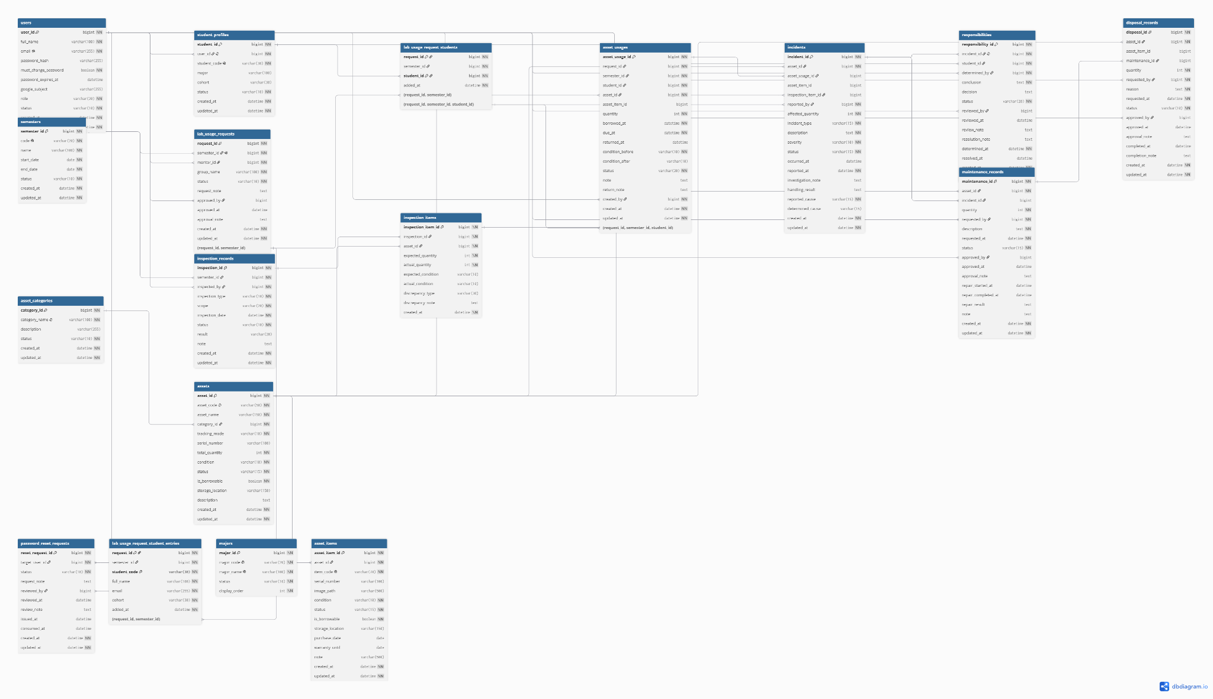

A centralized database for managing laboratory users, interns, equipment, borrowing activities, inspections, incidents, responsibilities, maintenance, and disposal. It ensures data consistency and provides complete tracking of laboratory assets throughout their lifecycle.

b. Table Descriptions
No | Table | Description
1 | users | Stores system users, authentication information, roles, and account status.
2 | password_reset_requests | Manages user password reset requests and approval status.
3 | student_profiles | Stores intern/student information linked to user accounts.
4 | majors | Stores the list of academic majors.
5 | semesters | Stores academic semester information and status.
6 | lab_usage_requests | Manages laboratory access requests submitted for each semester.
7 | Lab_usage_request_  students | Stores interns registered for a laboratory usage request.
8 | Lab_usage_request_  student_entries | Stores intern information snapshots submitted with a usage request.
9 | asset_categories | Stores categories used to classify laboratory assets.
10 | assets | Stores general information about laboratory equipment and assets.
11 | asset_items | Tracks individual physical items belonging to an asset.
12 | asset_usages | Records asset borrowing and returning transactions.
13 | inspection_records | Stores laboratory inspection and inventory records.
14 | inspection_items | Stores detailed asset inspection results and discrepancies.
15 | incidents | Records equipment damage, loss, malfunction, and other incidents.
16 | responsibilities | Manages responsibility determination and resolution for incidents.
17 | maintenance_records | Manages equipment repair and maintenance requests.
18 | disposal_records | Manages asset disposal requests, approvals, and completion.

3.2 Code Packages
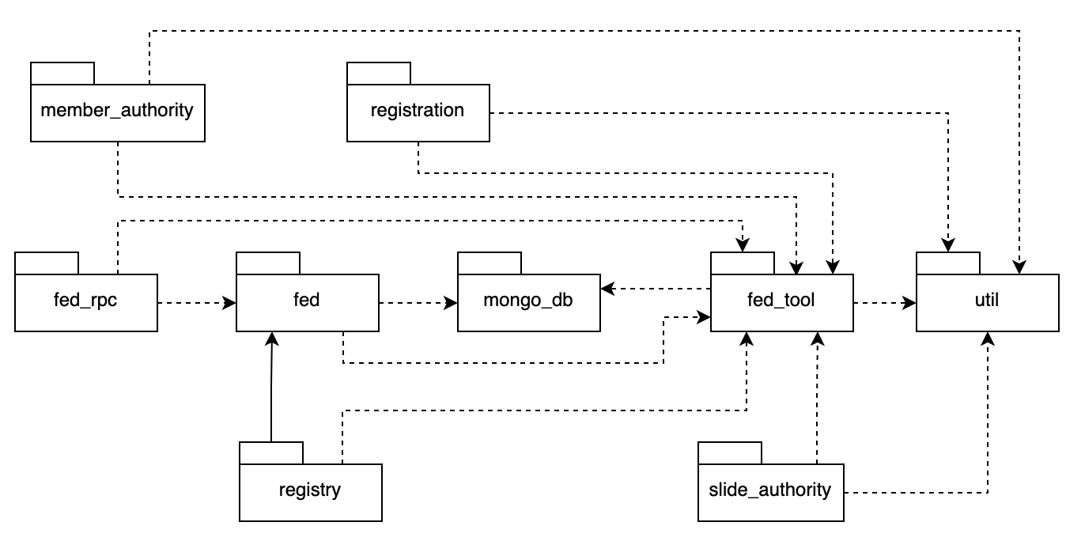
Package descriptions
No | Package | Description
1 | fpt.swp391.labtoolequip.controller | Controller dùng chung: cung cấp ảnh tài sản, hiển thị nội quy LAB và logic kiểm tra tài sản dùng chung.
2 | fpt.swp391.labtoolequip.controller.admin | Xử lý dashboard Admin, quản lý người dùng, phê duyệt danh sách Intern và cấp lại mật khẩu.
3 | fpt.swp391.labtoolequip.controller.auth | Đăng nhập/đăng xuất, đổi và quên mật khẩu, Google OAuth, callback và giới hạn lần đăng nhập.
4 | fpt.swp391.labtoolequip.controller.intern | Dashboard Intern, mượn/trả tài sản, báo cáo sự cố và xem thiết bị được cấp cho lớp.
5 | fpt.swp391.labtoolequip.controller.labmanager | Quản lý tài sản, cấp phát, kiểm kê, sự cố, bảo trì, thanh lý, sử dụng và trách nhiệm.
6 | fpt.swp391.labtoolequip.controller.mentor | Quản lý danh sách Intern, cấp phát, lượt sử dụng, sự cố, trách nhiệm, bảo trì và thanh lý.
7 | fpt.swp391.labtoolequip.controller.student | Package tương thích cũ; hiện vẫn phục vụ một số route xem tài sản và trách nhiệm của Intern.
8 | fpt.swp391.labtoolequip.auth | Quản lý session, permission, phân quyền theo vai trò, CSRF và bộ lọc bảo vệ route.
9 | fpt.swp391.labtoolequip.dao | Tầng truy cập SQL Server bằng JDBC; thực hiện CRUD, truy vấn và transaction nghiệp vụ.
10 | fpt.swp391.labtoolequip.model | Các đối tượng dữ liệu nghiệp vụ như User, Asset, AssetUsage, Incident, Maintenance và Allocation.
11 | fpt.swp391.labtoolequip.common | Kết nối database, đọc Excel, lưu ảnh, gửi email, format dữ liệu và xử lý encoding.
12 | util | AppConfig đọc cấu hình database, Google OAuth và thiết lập ứng dụng từ file .env.
13 | WEB-INF.views | Giao diện JSP/JSPF theo vai trò Admin, Intern, Mentor và Lab Manager; gồm trang dùng chung và trang lỗi.

II. Requirement Specifications

1. Manage Intern List

1.1 View Intern

a. Functionalities
UC ID and Name: | UC-03.1 View Intern List
Created By: | Nguyễn Minh Anh | Date Created: | 18/Aug/2026
Primary Actor: | Admin, Mentor | Secondary Actors:
Trigger: | Actor selects an Intern List from the Intern List screen.
Description: | Allows Admin or Mentor to view detailed information of an Intern List for a specific semester, including list status and registered interns.
Preconditions: | PRE-1: Actor has successfully logged in.  PRE-2: Actor has permission to access Intern List management.  PRE-3: The selected Intern List exists.
Postconditions: | POST-1: Intern List details are displayed.  POST-2: No data is modified.
Normal Flow: | 1. Actor opens the Intern List screen.  2. System displays available Intern Lists.  3. Actor selects an Intern List.  4. System retrieves the selected list and its intern members.  5. System displays semester, Mentor, status, submission information and intern details.
Alternative Flows: | 3.1 Actor searches or filters Intern Lists before selecting one. System displays matching results, then returns to Step 3.
Exceptions: | 3.0.E1: Intern List does not exist or has been deleted → System displays an error message and returns to the Intern List screen.  4.0.E1: Actor is not authorized → System denies access.
Priority: | High / Must Have
Frequency of Use: | Several times per semester, especially during Intern List submission and approval periods.
Business Rules: | BR-IL-01, BR-IL-02, BR-AUTH-01
Other Information: | Mentor can view the Intern List under their responsibility. Admin can view all Intern Lists for approval and management purposes.
Assumptions: | Semester and user information already exist in the system.

b. Business Rules
ID | Business Rule | Business Rule Description
BR-IL-01 | One Intern List per Semester | Only one Intern List may exist for the LAB in each semester.
BR-IL-02 | Intern List Access | Only authorized Admin and Mentor accounts may access Intern List information.
BR-AUTH-01 | Authorized Active Account | The user must have an existing ACTIVE account and the appropriate role before accessing protected functions.

1.2 List Intern

a. Functionalities
UC ID and Name: | UC-03.2 List Intern Lists
Created By: | Nguyễn Minh Anh | Date Created: | 18/Aug/2026
Primary Actor: | Admin, | Secondary Actors: | None
Trigger: | Actor opens the Manage Intern List screen.
Description: | Allows Admin and Mentor to view, search, and filter Intern Lists by semester and status, then select a list for detailed viewing or further permitted actions.
Preconditions: | PRE-1: Actor has successfully logged in.  PRE-2: Actor has permission to access Manage Intern List.
Postconditions: | POST-1: The system displays Intern Lists within the actor's access scope. POST-2: No business data is modified.
Normal Flow: | 1. Actor opens Manage Intern List.  2. System retrieves accessible Intern Lists.  3. System displays semester, Mentor, status, submitted date, and intern count. 4. Actor optionally enters search/filter criteria.  5. System refreshes the list with matching results.  6. Actor may select an Intern List to view details.
Alternative Flows: | 4.1 Actor leaves all filters blank → System displays all Intern Lists within the actor's access scope.  5.1 No matching Intern List is found → System displays an empty-result message.
Exceptions: | 2.0.E1 Actor is not authorized → System denies access.  2.0.E2 Data cannot be loaded → System displays an error message and keeps the current page available for retry.
Priority: | High / Must Have
Frequency of Use: | Several times per semester; usage is highest during Intern List submission and approval periods.
Business Rules: | BR-IL-01, BR-IL-02, BR-AUTH-01
Other Information: | Admin may view all Intern Lists. Mentor may view the Intern List under the Mentor's responsibility.
Assumptions: | Semester and authorized user data already exist in the system.

b. Business Rules
ID | Business Rule | Business Rule Description
BR-IL-01 | One Intern List per Semester | Only one Intern List may exist for the LAB in each semester.
BR-IL-02 | Intern List Access Scope | Admin may access all Intern Lists; Mentor may access the Intern List under the Mentor's responsibility.
BR-AUTH-01 | Authorized Active Account | Only an authenticated ACTIVE account with the appropriate system role may access protected functions.

1.3 Add Intern

a. Functionalities
UC ID and Name: | UC-03.3 Add Intern
Created By: | Nguyễn Minh Anh | Date Created: | 18/Aug/2026
Primary Actor: | Mentor | Secondary Actors: | None
Trigger: | Mentor opens a PENDING Intern List and chooses Add Intern.
Description: | Allows the Mentor to add an intern entry to the current semester's PENDING Intern List before the list is approved by Admin.
Preconditions: | PRE-1: Mentor has successfully logged in.  PRE-2: An Intern List exists for the semester.  PRE-3: The Intern List status is PENDING.
Postconditions: | POST-1: A valid intern entry is added to the PENDING Intern List.  POST-2: No INTERN account is activated solely by this action; account creation/activation occurs after Admin approval.
Normal Flow: | 1. Mentor opens a PENDING Intern List.  2. Mentor chooses Add Intern.  3. System displays fields for intern code, full name, Gmail, and cohort.  4. Mentor enters the required information and submits.  5. System validates required fields, email format, and duplicate intern code/Gmail in the semester.  6. System adds the intern entry to the list.  7. System refreshes the Intern List and shows the new entry.
Alternative Flows: | 4.1 Mentor cancels the operation → System returns to the Intern List without saving.  7.1 Mentor chooses Add Another Intern → System opens a new empty entry form.
Exceptions: | 5.0.E1 Intern code already exists in the same semester → System rejects the entry and shows a duplicate-code message.  5.0.E2 Gmail already exists in the same semester → System rejects the entry and shows a duplicate-email message.  5.0.E3 Intern List is no longer PENDING → System blocks the change and reloads the latest list status.
Priority: | High / Must Have
Frequency of Use: | Multiple times when the Mentor prepares the Intern List for a semester.
Business Rules: | BR-IL-03, BR-IL-04, BR-IL-05
Other Information: | Adding an intern to a PENDING list does not grant LAB access. Access is granted only after Admin approves the whole Intern List and the system creates or activates the INTERN account.
Assumptions: | The semester and its Intern List have already been created and the list has not yet been approved.

b. Business Rules
ID | Business Rule | Business Rule Description
BR-IL-03 | Pending List Editable by Mentor | Mentor may add, edit, or delete intern entries only while the Intern List status is PENDING.
BR-IL-04 | Unique Intern Code and Gmail | Intern code and Gmail must not be duplicated within the same semester.
BR-IL-05 | Approval Required for Access | Adding an intern to the list does not grant LAB access; the whole list must be approved by Admin before the intern can access and borrow assets.

1.4 Edit Intern List

a. Functionalities
UC ID and Name: | UC-03.4 Edit Intern List
Created By: | Nguyễn Minh Anh | Date Created: | 18/Aug/2026
Primary Actor: | Admin, Mentor | Secondary Actors:
Trigger: | Actor selects an existing Intern List and chooses Edit.
Description: | Allows an authorized Admin or Mentor to update Intern List information and intern members for a semester according to the list status and role permissions.
Preconditions: | PRE-1: Actor is logged in with an ACTIVE authorized account.  PRE-2: The selected Intern List exists.  PRE-3: Mentor may edit only when the Intern List status is PENDING.  PRE-4: Admin may edit the Intern List in any status.
Postconditions: | POST-1: Valid changes are saved to the Intern List.  POST-2: If Admin edits an APPROVED list, intern membership/account linkage is synchronized with the updated data.
Normal Flow: | 1. Actor opens the Intern List screen.  2. System displays existing Intern Lists.  3. Actor selects an Intern List and chooses Edit.  4. System checks the actor's role and the list status.  5. System displays the current list information and intern members.  6. Actor updates list information and/or intern member data.  7. Actor submits the changes.  8. System validates the updated data.  9. System saves the changes.  10. System displays the updated Intern List.
Alternative Flows: | 4.1 Admin edits an APPROVED Intern List: after saving, the system synchronizes intern membership with the updated approved list.  7.1 Actor cancels editing: system discards unsaved changes and returns to the Intern List details/list screen.
Exceptions: | 4.0.E1 Mentor attempts to edit a non-PENDING list → System denies the operation.  8.0.E1 Duplicate intern code exists in the same semester → System rejects the submission and shows a validation message.  8.0.E2 Duplicate Gmail exists in the same semester → System rejects the submission and shows a validation message.  9.0.E1 The list no longer exists or was changed in a way that prevents the update → System shows an error and does not save invalid changes.
Priority: | High/ Must Have
Frequency of Use: | Occasional; mainly during Intern List preparation, correction, and administrative updates within a semester.
Business Rules: | BR-IL-01, BR-IL-02, BR-IL-03, BR-IL-04, BR-AUTH-01
Other Information: | Mentor editing is restricted to PENDING lists. Admin has the highest authority over Intern Lists and may edit lists in any status. Editing an APPROVED list by Admin requires membership synchronization.
Assumptions: | Semester information and the Intern List already exist in the system.

b. Business Rules
ID | Business Rule | Business Rule Description
BR-IL-01 | One Intern List per Semester | Only one Intern List may exist for the LAB in each semester.
BR-IL-02 | Mentor Edit Restriction | Mentor may edit an Intern List only while its status is PENDING.
BR-IL-03 | Admin Edit Authority | Admin may edit an Intern List in any status.
BR-IL-04 | Unique Intern Data | Intern code and Gmail must not be duplicated within the same semester.
BR-IL-05 | Approved List Synchronization | When Admin edits an APPROVED Intern List, intern membership must be synchronized with the updated approved data.
BR-AUTH-01 | Authorized Active Account | Only an authorized user with an ACTIVE account and the required role may access protected functions.

2. Manage Users

2.1 List Users

a. Functionalities

UC ID / UC Name | UC-01: List Users
Primary Actor | Admin
Secondary Actor | None
Description | Allows the admin to search, filter by multiple criteria (keyword, role, status), and view a paginated list of all user accounts within the system.
Trigger | The Admin navigates to the Manage Users section (/admin/users).
Preconditions | 1. The Admin is authenticated with a valid session.  2. The authenticated user possesses the 'ADMIN' role.
Success Postconditions | The list of user accounts matching the specified filter/search criteria is displayed with correct pagination controls and summary counters.
Main Flow | 1. Admin accesses the Manage Users.  2. System renders the user list view with dynamic pagination controls.  3. Admin views the list, adjusts entries per page (5, 10, 25, 50), or navigates across pages.
Alternative Flows | ALT-1: Search and Filter Users: Actor enters a search term (Full name, Email, Student code) and/or selects Role and Status filters, then clicks "Filter".
Exception Flows | None
Business Rules | BR--01: Only accounts with the 'ADMIN' role are authorized to access the user directory.  BR-02: The default list view displays both ACTIVE and INACTIVE accounts.  BR-03: Pagination must dynamically calculate total pages based on actual records (totalPages = ceil(totalRecords / pageSize)).

b. Business Rules
ID | Business Rule | Business Rule Description

2.2 View User

a. Functionalities

UC ID / UC Name | UC-02: View User
Primary Actor | Admin
Secondary Actor | None
Description | Allows the admin to view the complete personal identity, system role, academic profile (for Interns), Google OAuth association status, and audit timestamps of a specific user account.
Trigger | Admin clicks the "View" button for a specific user row on the user list table.
Preconditions | 1. Admin is logged in with ADMIN privileges.  2. The targeted user account exists in the database.
Success Postconditions | The user detail screen is rendered, displaying comprehensive, accurate, read-only information for the selected user.
Main Flow | 1. Actor: Clicks the "View" button on the user list table.  2. System: UserController.showDetail extracts and validates the id parameter.  3. System: Calls UserDAO.findById(userId) performing a LEFT JOIN between dbo.users and dbo.student_profiles.  4. System: Populates the User domain object and forwards to the detail view (detail.jsp).  5. Actor: Reviews all personal, role, academic, and audit information of the user.
Alternative Flows | ALT-1: User is an Intern  • System displays the academic section including Student Code, Major, and Cohort.  ALT-2: User is a Mentor, Lab Manager, or Admin  • System displays organizational scope / faculty role and omits student academic fields.
Exception Flows | EX-1: User Not Found (Invalid ID or Deleted Record)  • 1a. UserDAO.findById returns Optional.empty().  • 2a. System returns an HTTP 404 Not Found response.  EX-2: Invalid ID Format  • 1b. The id parameter is non-numeric or malformed.  • 2b. System catches a NumberFormatException and returns HTTP 400 Bad Request.
Business Rules | • BR-01: Only ADMIN users possess permission to view detailed account information.  • BR-04: All fields displayed on the Detail view are strictly read-only; no data modifications can be performed on this screen.

b. Business Rules
ID | Business Rule | Business Rule Description

2.3 Add User

a. Functionalities

UC ID / UC Name | UC-03: Add User
Primary Actor | Admin
Secondary Actor | None
Description | Allows the Admin to create a new user account profile with an assigned system role (INTERN, MENTOR, LAB_MANAGER) and an initial account status, delegating authentication to Google OAuth2.
Trigger | Admin selects the "Add New User" action from the user management directory.
Preconditions | 1. Admin is successfully logged in with an active administrator session.  2. Admin has granted administrative privileges (role = 'ADMIN').
Success Postconditions | 1. A new user record is persisted in dbo.users with status ACTIVE or INACTIVE.  2. If the role is INTERN, a corresponding student profile is created in dbo.student_profiles.  3. The user is authorized to sign in with Google using their designated email.
Main Flow | 1. Admin navigates to the "Add User" form.  2. System displays input fields for Full Name, Role selection, Email address, and Initial Status.  3. Admin enters Full Name, selects Role (INTERN, MENTOR, or LAB_MANAGER), enters the user's official email address, and selects initial status.  4. Admin submits the form by clicking "Create User Account".  5. System validates all input data against business constraints.  6. System persists the new user profile (and student academic profile if applicable).  7. System redirects Admin back to the Users List with a success confirmation message.
Alternative Flows | AL-1: Creating an Intern Account (INTERN)  • At step 2, when Admin selects INTERN, System dynamically reveals Student Roll Number, Major, and Cohort fields.  • At step 3, Admin enters Student Roll Code and academic details, ensuring email ends with @fpt.edu.vn.  • Flow resumes at step 4.  AL-2: Creating a Staff Account (MENTOR or LAB_MANAGER)  • At step 2, when Admin selects MENTOR or LAB_MANAGER, System hides student-specific fields.  • At step 3, Admin enters a valid university email (@fpt.edu.vn) or standard Gmail address (@gmail.com).  • Flow resumes at step 4.
Exception Flows | EX-1: Missing Mandatory Fields  • At step 5, if Full Name, Email, or Student Code (for Intern) is blank, System halts creation and displays descriptive validation error messages.  EX-2: Invalid Email Domain for Intern  • At step 5, if role is INTERN but email does not end with @fpt.edu.vn, System displays: "Email của sinh viên thực tập (Intern) bắt buộc phải có định dạng @fpt.edu.vn."  EX-3: Duplicate Email or Student Code  • At step 6, if the email address or student code already exists in the database, System rolls back transaction and displays: "Không thể lưu người dùng. Email hoặc mã sinh viên có thể đã tồn tại."
Business Rules | BR-01: Password-free account provisioning (authentication is strictly delegated to Google OAuth2).  BR-02: Email cannot be blank and is not auto-generated; manual entry is mandatory.  BR-03: Interns require an official @fpt.edu.vn email and unique student roll number.  BR-04: Mentors and Lab Managers may use either @fpt.edu.vn or @gmail.com.

b. Business Rules
ID | Business Rule | Business Rule Description
FR1 | Password Encoding | User’s password must be encoded with MD5 hashing

2.4 Edit User

a. Functionalities

UC ID / UC Name | UC-USER-04: Edit User
Primary Actor | Admin
Secondary Actor | None
Description | Allows the admin to modify the assigned system role and active/inactive status of an existing user while enforcing strict immutability on personal identity attributes.
Trigger | Admin clicks the "Edit" action button next to a specific user record on the user directory table.
Preconditions | 1. Admin is authenticated with an active session.  2. The target user record exists in dbo.users.
Success Postconditions | 1. The user's role and/or account status are updated in dbo.users.  2. If status changed to INACTIVE, the target user is immediately blocked from logging in or performing actions.
Main Flow | 1. Admin clicks "Edit" for a user in the User List.  2. System retrieves user details and displays the Edit form.  3. System renders personal identity fields (Full Name, Email, Student Roll Number, Major, Cohort) as locked, read-only fields.  4. Admin modifies the Role (if permitted) and/or toggles Status between ACTIVE and INACTIVE.  5. Admin submits changes by clicking "Save Changes".  6. System validates role transition rules and status values.  7. System updates the database record and redirects Admin to User List with a success notice.
Alternative Flows | AL-1: Role Transition between Mentor and Lab Manager  • At step 4, if target user is currently a MENTOR or LAB_MANAGER, System provides a dropdown to switch role to LAB_MANAGER or MENTOR.  • Flow resumes at step 5.  AL-2: Locking / Unlocking Account Status  • At step 4, Admin switches Status from ACTIVE to INACTIVE (Lock) or INACTIVE to ACTIVE (Unlock).  • Flow resumes at step 5.
Exception Flows | EX-1: User Record Not Found  • At step 2, if the user ID is invalid or does not exist, System returns HTTP 404 (Not Found).  EX-2: Prohibited Role Transition for Intern or Admin  • At step 4/6, if target user is INTERN or ADMIN, role selection is locked/enforced server-side to maintain original role.
Business Rules | BR-05: Personal identity data (Full Name, Email, Student Code) is immutable and cannot be altered during edit.  BR-06: INTERN role is permanent and cannot be converted to MENTOR or LAB_MANAGER.  BR-07: ADMIN role is fixed and immutable.  BR-08: Role switching is exclusively permitted bidirectionally between MENTOR and LAB_MANAGER.  BR-09: Setting status to INACTIVE immediately revokes access without deleting historical transaction traces.

b. Business Rules
ID | Business Rule | Business Rule Description
FR1 | Password Encoding | User’s password must be encoded with MD5 hashing

3. Manage Asset

3.1 View Asset

a. Functionalities
UC ID and Name: | UC-AM-01 - List Asset Items
Created By: | Nguyễn Minh Anh | Date Created: | 18/08/2026
Primary Actor: | Lab Manager, Mentor, and Intern | Secondary Actors:
Trigger: | The actor opens the Asset Management page or Asset Catalog page.
Description: | Displays a role-filtered list of physical Asset Items. The list shows an image, item code, asset name, category, serial information when applicable, condition, and operational status.
Preconditions: | The actor is logged in. The actor has permission to access the relevant role portal.
Postconditions: | No asset data is changed. The actor receives the current list of accessible Asset Items.
Normal Flow: | - The actor opens the list of assets available to the actor's role.  - The actor optionally enters a keyword and selects available filters such as category, condition, or status.  - The actor submits the search or filter request.  - The system displays matching Asset Items with their current image and status information.  - The actor may select an Asset Item to view its full details.
Alternative Flows: | - If the actor leaves all filters blank, the system displays all Asset Items permitted for that role.  - If no Asset Items match the keyword or filter values, the system shows an empty-state message and keeps the filters available for adjustment.  - For an Intern, the list excludes fixed assets and items that are not eligible for borrowing.
Exceptions:
Priority: | High (Medium, Low), Must Have (Should Have, Could Have),..
Frequency of Use:
Business Rules:
Other Information:
Assumptions:

b. Business Rules
ID | Business Rule | Business Rule Description
FR1 | Password Encoding | User’s password must be encoded with MD5 hashing

3.2 List Asset

a. Functionalities
UC ID and Name:
Created By: |  | Date Created:
Primary Actor: |  | Secondary Actors:
Trigger:
Description:
Preconditions:
Postconditions:
Normal Flow:
Alternative Flows:
Exceptions:
Priority: | High (Medium, Low), Must Have (Should Have, Could Have),..
Frequency of Use:
Business Rules:
Other Information:
Assumptions:

b. Business Rules
ID | Business Rule | Business Rule Description
FR1 | Password Encoding | User’s password must be encoded with MD5 hashing

3.3 Add Asset

a. Functionalities
UC ID and Name:
Created By: |  | Date Created:
Primary Actor: |  | Secondary Actors:
Trigger:
Description:
Preconditions:
Postconditions:
Normal Flow:
Alternative Flows:
Exceptions:
Priority: | High (Medium, Low), Must Have (Should Have, Could Have),..
Frequency of Use:
Business Rules:
Other Information:
Assumptions:

b. Business Rules
ID | Business Rule | Business Rule Description
FR1 | Password Encoding | User’s password must be encoded with MD5 hashing

3.4 Edit Asset

a. Functionalities
UC ID and Name:
Created By: |  | Date Created:
Primary Actor: |  | Secondary Actors:
Trigger:
Description:
Preconditions:
Postconditions:
Normal Flow:
Alternative Flows:
Exceptions:
Priority: | High (Medium, Low), Must Have (Should Have, Could Have),..
Frequency of Use:
Business Rules:
Other Information:
Assumptions:

b. Business Rules
ID | Business Rule | Business Rule Description
FR1 | Password Encoding | User’s password must be encoded with MD5 hashing

4. Manage Asset Usage

4.1 View Asset Usage

a. Functionalities
UC ID and Name: | UC-04.1 View Asset Usage
Created By: | Lương Anh Minh | Date Created: | 17/08/2026
Primary Actor: | Lab Manager, Mentor, Intern | Secondary Actors:
Trigger: | Actor selects an asset usage transaction.
Description: | Displays the intern, asset, quantity, borrowed time, due time, return information, conditions, status, and notes.
Preconditions: | Actor is authenticated; transaction exists; actor has access to the transaction.
Postconditions: | Transaction details are displayed; no data is modified.
Normal Flow: | 1. Actor opens the usage list.  2. Actor selects a transaction.  3. System checks access scope.  4. System retrieves and displays details.
Alternative Flows: | Intern views only their own transaction. Mentor views only transactions of interns supervised through an approved Intern List. Lab Manager may view any transaction.
Exceptions: | Transaction not found or outside actor scope: system returns Not Found or denies access. Database failure: system reports an error.
Priority: | High / Must Have
Frequency of Use: | Frequently during borrowing, monitoring, and returns.
Business Rules: | BR-AU-01, BR-AU-02
Other Information:
Assumptions: | Related user, Intern List, semester, and asset data exist.

b. Business Rules
ID | Business Rule | Business Rule Description
BR-AU-01 | Usage Access Scope | Intern may view only their own usage; Mentor may view usage of supervised interns; Lab Manager may view all usage.
BR-AU-02 | Usage History Preservation | Borrowing and return records remain available for monitoring and history.

4.2 List Asset Usage

a. Functionalities
UC ID and Name: | UC-04.2 List Asset Usage
Created By: | Lương Anh Minh | Date Created: | 17/08/2026
Primary Actor: | Lab Manager, Mentor, Intern | Secondary Actors:
Trigger: | Actor opens the Asset Usage screen.
Description: | Lists, searches, and filters usage history by intern, asset, status, or usage time within the actor's scope.
Preconditions: | Actor is authenticated and has Asset Usage view permission.
Postconditions: | Matching records are displayed; no data is modified.
Normal Flow: | 1. Actor opens Asset Usage.  2. System retrieves accessible records.  3. System displays transaction summary.  4. Actor may search/filter.  5. System displays matching records.
Alternative Flows: | Blank criteria display all records in scope. No matches display an empty state.
Exceptions: | Unauthorized actor is denied. Data retrieval failure displays an error.
Priority: | High / Must Have
Frequency of Use: | Daily
Business Rules: | BR-AU-01, BR-AU-02
Other Information: | Intern list is the Intern's personal history; Mentor list is limited to supervised interns.
Assumptions:

b. Business Rules
ID | Business Rule | Business Rule Description
BR-AU-01 | Usage Access Scope | Results must be restricted by actor responsibility, not only by UI filtering.
BR-AU-02 | Read-only Monitoring | Mentor and Lab Manager monitor usage; they do not borrow or return on an Intern's behalf.

4.3 Borrow / Declare Asset Usage

a. Functionalities
UC ID and Name: | UC-04.3 Borrow / Declare Asset Usage
Created By: | Lương Anh Minh | Date Created: | 17/08/2026
Primary Actor: | Intern | Secondary Actors:
Trigger: | Intern chooses Borrow for an available asset.
Description: | Records that an authorized Intern takes an available, borrowable asset for their own use; no per-borrow approval occurs.
Preconditions: | Intern account and profile are ACTIVE; Intern belongs to an approved Intern List in the active semester; asset is AVAILABLE, borrowable, in GOOD or FAIR condition, and has sufficient quantity; no pending/approved disposal blocks it.
Postconditions: | One Asset Usage record is created with status IN_USE; transaction references the current approved Intern List and semester; available quantity is reduced logically by active usage.
Normal Flow: | 1. Intern opens Borrow Asset.  2. System displays eligible assets/items.  3. Intern selects asset, quantity, and optional note.  4. System validates CSRF, eligibility, asset state, and quantity inside a transaction.  5. System locks the asset, creates IN_USE usage, and confirms success.
Alternative Flows: | Serialized asset requires one eligible asset item. Quantity-tracked asset accepts a positive quantity up to remaining stock.
Exceptions: | Ineligible Intern, invalid quantity, unavailable asset, pending disposal, or concurrent over-borrow: system rolls back and displays the validation message.
Priority: | High / Must Have
Frequency of Use: | Whenever an Intern takes an asset.
Business Rules: | BR-AU-03, BR-AU-04, BR-AU-05, BR-AU-06
Other Information: | Intern can borrow only for themselves.
Assumptions:

b. Business Rules
ID | Business Rule | Business Rule Description
BR-AU-03 | Intern Eligibility | Borrower must be an ACTIVE Intern in an APPROVED Intern List for the ACTIVE semester.
BR-AU-03 | Asset Eligibility | Asset must be AVAILABLE, borrowable, GOOD or FAIR, and not blocked by disposal or maintenance.
BR-AU-05 | Prevent Over-borrowing | Active borrowed quantity plus requested quantity must not exceed total quantity; validation uses transactional locking.
BR-AU-06 | No Borrow Approval | A valid declaration immediately creates an IN_USE transaction without Mentor or Lab Manager approval.

4.4 Return Asset

a. Functionalities
UC ID and Name: | UC-04.4 Return Asset
Created By: | Lương Anh Minh | Date Created: | 17/08/2026
Primary Actor: | Intern | Secondary Actors:
Trigger: | Intern chooses Return on one of their active usage transactions.
Description: | Records return time, condition after use, status, and return note.
Preconditions: | Usage exists, belongs to the current Intern, has status IN_USE, and has not been returned.
Postconditions: | Usage status becomes RETURNED; returned time and valid condition are stored; returned asset/item becomes available when condition permits.
Normal Flow: | 1. Intern opens their usage detail.  2. Intern chooses Return.  3. Intern selects condition and enters optional note.  4. System validates ownership, active status, and condition.  5. System records return and confirms success.
Alternative Flows: | GOOD or FAIR condition returns the item to AVAILABLE. DAMAGED or BROKEN condition marks the serialized item UNAVAILABLE for follow-up.
Exceptions: | Transaction belongs to another Intern, is already returned, or condition is invalid: system makes no change and displays an error.
Priority: | High / Must Have
Frequency of Use: | Whenever an Intern returns an asset.
Business Rules: | BR-AU-07, BR-AU-08
Other Information: | Mentor and Lab Manager may view the completed transaction but cannot return it for the Intern.
Assumptions:

b. Business Rules
ID | Business Rule | Business Rule Description
BR-AU-07 | Return Ownership | Intern may return only their own IN_USE transaction.
BR-AU-08 | Return Condition | Condition after return must be GOOD, FAIR, DAMAGED, or BROKEN and must be retained in usage history.

5. Manage Asset Inspections and Inventories

5.1 View Asset Inspection and Inventory

a. Functionalities
UC ID and Name: | UC-05.1 View Asset Inspection and Inventory
Created By: |  | Date Created:
Primary Actor: | Lab Manager, Mentor | Secondary Actors: | None
Trigger: | Actor selects an inspection or inventory record from the Inspection & Inventory List screen.
Description: | Allows an authorized actor to view complete information of an inspection or inventory record, including its type, semester, scope, inspector, status, result, note, and inspected asset items.
Preconditions: | PRE-1: Actor has successfully logged in. PRE-2: Actor has permission to access inspection and inventory management. PRE-3: The selected inspection or inventory record exists.
Postconditions: | POST-1: Inspection or inventory details are displayed. POST-2: No inspection data is modified.
Normal Flow: | 1. The actor opens the Inspection & Inventory List screen.  2. The system displays available records.  3. Actor selects View on a record.  4. The system retrieves the inspection header and related inspection items.  5. System displays type, semester, scope, inspector, inspection date, status, result and note.  6. System displays each inspected asset with expected quantity, actual quantity, expected condition, actual condition, discrepancy type and discrepancy note.  7. If the record is still DRAFT, the system provides an Edit Draft action.
Alternative Flows: | 4.1. If the record is COMPLETED, the system displays the information in read-only mode and does not provide editing actions. 6.1. If an inspection item has a discrepancy, the system displays its discrepancy information.
Exceptions: | 3.0.E1: Selected record does not exist → System displays an error or returns the actor to the list. 3.0.E2: Actor is not authorized → System denies access.
Priority: | High / Must Have
Frequency of Use: | Frequently, especially during inspection, inventory, incident investigation, and asset review activities.
Business Rules: | BR-INSP-01, BR-INSP-03, BR-INSP-08, BR-INSP-10
Other Information: | A completed inspection may later be used as evidence when reporting or investigating an asset incident.
Assumptions: | Semester, user and asset information already exist in the system.

b. Business Rules
ID | Business Rule | Business Rule Description
BR-INSP  -01 | Inspection Access | Only authorized LAB_MANAGER and MENTOR accounts may access inspection and inventory management functions.
BR-INSP  -03 | Inspection Lifecycle | An inspection record has status DRAFT or COMPLETED. A DRAFT record has no final result; a COMPLETED record must have a valid final result.
BR-INSP  -08 | Completed Record Is Read-only | A completed inspection or inventory record cannot be edited through the normal inspection management workflow.
BR-INSP  -10 | Asset Condition Values | Asset condition values used in inspection items must be one of GOOD, FAIR, DAMAGED, or BROKEN.

5.2 List Asset Inspection and Inventory

a. Functionalities
UC ID and Name: | UC-05.2 List Asset Inspection and Inventory
Created By: |  | Date Created:
Primary Actor: | Lab Manager, Mentor | Secondary Actors:
Trigger: | Actor opens the Inspection & Inventory management screen.
Description: | Allows an authorized actor to view, search and filter inspection and inventory records.
Preconditions: | PRE-1: Actor has successfully logged in. PRE-2: Actor has permission to access inspection and inventory management.
Postconditions: | POST-1: Matching inspection and inventory records are displayed. POST-2: No inspection data is modified.
Normal Flow: | 1. The actor opens the Inspection & Inventory screen.  2. The system retrieves inspection and inventory records.  3. The system displays Inspection ID, type, semester, scope, inspection date, inspector, status and result.  4. Actors may select a record to view its details.  5. For a DRAFT record, the system also displays an Edit action.
Alternative Flows: | 2.1. The actor filters records by semester, inspection type, status, result or date range.  2.2. The system retrieves and displays only records matching the filter conditions.  2.3. Actor selects Reset → System clears filters and displays the default record list.
Exceptions: | 2.0.E1: No record matches the search criteria → System displays an empty result message.  2.0.E2: Actor is not authorized → System denies access.
Priority: | High / Must Have
Frequency of Use: | Frequently during LAB operations.
Business Rules: | BR-INSP-01, BR-INSP-03, BR-INSP-08
Other Information: | Both INSPECTION and INVENTORY records are displayed on the same management screen.
Assumptions: | At least one active semester may exist in the system.

b. Business Rules
ID | Business Rule | Business Rule Description
BR-INSP-01 | Inspection Access | Only authorized Lab Manager and Mentor accounts may access inspection and inventory records.
BR-INSP-03 | Inspection Lifecycle | Records are classified as DRAFT or COMPLETED; only draft records may expose an Edit action.
BR-INSP-08 | Completed Record Is Read-only | COMPLETED inspection records may be viewed but not edited.

5.3 Add Asset Inspection and Inventory

a. Functionalities
UC ID and Name: | UC-05.3 Add Asset Inspection and Inventory
Created By: | TrungND | Date Created: | 17/0802026
Primary Actor: | Lab Manager, Mentor | Secondary Actors:
Trigger: | Actor selects Create Inspection from the Inspection & Inventory screen.
Description: | Allows an authorized actor to create a new inspection or inventory for the whole LAB or a selected group of assets, enter observed quantities and conditions, and either save the record as a draft or complete it.
Preconditions: | PRE-1: Actor has successfully logged in.  PRE-2: Actor has permission to manage inspections and inventories.  PRE-3: A valid semester exists.  PRE-4: At least one non-disposed asset exists.
Postconditions: | POST-1: A new inspection record and its related inspection items are created. POST-2: If Save Draft is selected, status is DRAFT and result is NULL.  POST-3: If Complete Inspection is selected, status is COMPLETED and result is automatically determined as NORMAL or DISCREPANCY_FOUND.
Normal Flow: | 1. The actor opens the Inspection & Inventory screen.  2. Actor selects Create Inspection.  3. The system displays the creation form.  4. The actor selects Semester.  5. The actor selects Inspection Type: INSPECTION or INVENTORY.  6. Actor selects Scope: WHOLE_LAB or SELECTED_ASSETS.  7. The actor enters an inspection date and optional note.  8. The system displays eligible non-disposed assets.  9. The actor records the actual quantity and actual condition for the inspection items.  10. The actor records discrepancy type/note when necessary.  11. The actor selects Save Draft or Complete Inspection.  12. The system validates all entered data.  13. The system creates the inspection record and inspection items within one transaction.  14. The system redirects the actor to the inspection detail screen.
Alternative Flows: | 6.1. If scope is WHOLE_LAB, the system automatically includes all eligible non-disposed assets.  6.2. If scope is SELECTED_ASSETS, the actor selects one or more assets to inspect.  11.1. Actor selects Save Draft → System saves the record as DRAFT without a final result.  11.2. The actor selects Complete Inspection → System compares inspection items and determines the final result.  11.3. If all items have matching expected/actual information → result is NORMAL.  11.4. If at least one item contains a discrepancy → result is DISCREPANCY_FOUND.
Exceptions: | 4.0.E1: Invalid semester → System rejects the request.  6.0.E1: Selected-assets scope contains no selected asset → System requests at least one asset.  8.0.E1: Disposed asset is submitted → System rejects the asset.  9.0.E1: Quantity is negative → System displays a validation error.  9.0.E2: The same asset occurs more than once → System rejects duplicate inspection items.  13.0.E1: Database operation fails → Transaction is rolled back and no partial inspection is created.
Priority: | High / Must Have
Frequency of Use: | Several times per semester or whenever LAB inspection/inventory is required.
Business Rules: | BR-INSP-01, BR-INSP-02, BR-INSP-03, BR-INSP-04, BR-INSP-05, BR-INSP-06, BR-INSP-07, BR-INSP-09, BR-INSP-10
Other Information: | Inspection records are not associated with seats because the system does not manage LAB seating.
Assumptions: | Asset master data and semester data are already available.

b. Business Rules
ID | Business Rule | Business Rule Description
BR-INSP-01 | Inspection Access | Only authorized Lab Manager and Mentor accounts may create inspection or inventory records.
BR-INSP-02 | Inspection Type and Scope | Inspection type must be INSPECTION or INVENTORY. Scope must be WHOLE_LAB or SELECTED_ASSETS.
BR-INSP-03 | Inspection Lifecycle | DRAFT records must have result = NULL. COMPLETED records must have result NORMAL or DISCREPANCY_FOUND.
BR-INSP-04 | Unique Asset per Inspection | The same asset may appear only once within one inspection record.
BR-INSP-05 | Valid Inspection Quantity | Expected and actual quantities must not be negative.
BR-INSP-06 | Disposed Asset Exclusion | Assets with lifecycle status DISPOSED must not be included as active inspection targets.
BR-INSP-07 | Automatic Inspection Result | A completed inspection is NORMAL when no inspection item contains a discrepancy; otherwise the result is DISCREPANCY_FOUND.
BR-INSP-09 | Scope Asset Selection | WHOLE_LAB includes all eligible non-disposed assets. SELECTED_ASSETS requires at least one explicitly selected asset.
BR-INSP-10 | Asset Condition Values | Expected and actual condition must use the supported values GOOD, FAIR, DAMAGED, or BROKEN.

5.4 Edit Asset Inspection and Inventory

a. Functionalities
UC ID and Name:
Created By: | TrungND | Date Created: | 17/08/2026
Primary Actor: | Lab Manager, Mentor | Secondary Actors:
Trigger: | The actor selects Edit or Edit Draft for an inspection whose status is DRAFT.
Description: | Allows an authorized actor to modify an existing draft inspection or inventory, update inspection items, and either keep it as a draft or complete the inspection.
Preconditions: | PRE-1: Actor has successfully logged in.  PRE-2: Actor has permission to manage inspections and inventories.  PRE-3: The selected inspection record exists.  PRE-4: The selected inspection has status DRAFT.
Postconditions: | POST-1: Updated header and inspection item information is stored.  POST-2: If saved as draft, status remains DRAFT and result remains NULL. POST-3: If completed, status becomes COMPLETED and result becomes NORMAL or DISCREPANCY_FOUND.
Normal Flow: | 1. The actor opens a draft inspection.  2. Actor selects Edit Draft.  3. The system retrieves the current inspection header and inspection items.  4. The system displays existing information in the edit form.  5. The actor modifies permitted fields and inspection item values.  6. The actor selects Save Draft or Complete Inspection.  7. The system validates the modified information.  8. The system updates the inspection record and inspection items transactionally.  9. The system redirects the actor to the inspection detail screen.
Alternative Flows: | 6.1. Save Draft → Record remains DRAFT with no final result.  6.2. Complete Inspection → System determines NORMAL or DISCREPANCY_FOUND.  6.3. Actor selects Cancel → System discards unsaved changes and returns to the previous screen.
Exceptions:
Priority: | High (Medium, Low), Must Have (Should Have, Could Have),..
Frequency of Use:
Business Rules:
Other Information:
Assumptions:

b. Business Rules
ID | Business Rule | Business Rule Description
FR1 | Password Encoding | User’s password must be encoded with MD5 hashing

6. Manage Asset Incidents

6.1 View Asset Incident

a. Functionalities
UC ID and Name:
Created By: |  | Date Created:
Primary Actor: |  | Secondary Actors:
Trigger:
Description:
Preconditions:
Postconditions:
Normal Flow:
Alternative Flows:
Exceptions:
Priority: | High (Medium, Low), Must Have (Should Have, Could Have),..
Frequency of Use:
Business Rules:
Other Information:
Assumptions:

b. Business Rules
ID | Business Rule | Business Rule Description
FR1 | Password Encoding | User’s password must be encoded with MD5 hashing

6.2 List Asset Incident

a. Functionalities
UC ID and Name:
Created By: |  | Date Created:
Primary Actor: |  | Secondary Actors:
Trigger:
Description:
Preconditions:
Postconditions:
Normal Flow:
Alternative Flows:
Exceptions:
Priority: | High (Medium, Low), Must Have (Should Have, Could Have),..
Frequency of Use:
Business Rules:
Other Information:
Assumptions:

b. Business Rules
ID | Business Rule | Business Rule Description
FR1 | Password Encoding | User’s password must be encoded with MD5 hashing

6.3 Add Asset Incident

a. Functionalities
UC ID and Name:
Created By: |  | Date Created:
Primary Actor: |  | Secondary Actors:
Trigger:
Description:
Preconditions:
Postconditions:
Normal Flow:
Alternative Flows:
Exceptions:
Priority: | High (Medium, Low), Must Have (Should Have, Could Have),..
Frequency of Use:
Business Rules:
Other Information:
Assumptions:

b. Business Rules
ID | Business Rule | Business Rule Description
FR1 | Password Encoding | User’s password must be encoded with MD5 hashing

6.4 Edit Asset Incident

a. Functionalities
UC ID and Name:
Created By: |  | Date Created:
Primary Actor: |  | Secondary Actors:
Trigger:
Description:
Preconditions:
Postconditions:
Normal Flow:
Alternative Flows:
Exceptions:
Priority: | High (Medium, Low), Must Have (Should Have, Could Have),..
Frequency of Use:
Business Rules:
Other Information:
Assumptions:

b. Business Rules
ID | Business Rule | Business Rule Description
FR1 | Password Encoding | User’s password must be encoded with MD5 hashing

7. Manage Responsibilities

7.1 View Responsibility

a. Functionalities
UC ID and Name: | UC-07.1: View Responsibility
Created By: | DucTM | Date Created: | 17/08/2026
Primary Actor: | Lab Manager, Mentor, Intern | Secondary Actors: | None
Trigger: | The actor selects the View action for a responsibility record.
Description: | Allows an authorized actor to view the complete responsibility record related to an incident, Intern, asset usage, investigation finding, handling decision, review information, and resolution result.
Preconditions: | The actor is authenticated with an active Lab Manager, Mentor, or Intern account; the responsibility record exists.
Postconditions: | The responsibility details are displayed without changing stored data; the actor remains on an authorized page.
Normal Flow: | - The actor opens the Responsibilities or My Responsibilities list.  - The system determines the actor's role and permitted data scope from the authenticated session.  - The actor selects View in the Action column for a record.  - The system validates that the actor may access the selected record.  - The system retrieves the responsibility together with its incident, Intern, asset, asset usage, Mentor, review, and resolution information.  - The system displays the responsibility details in read-only form.
Alternative Flows: | - A1: The actor returns to the responsibility list without modifying the record.  - A2: If optional review or resolution information is unavailable, the system displays an empty or Not Available value while retaining the remaining details.
Exceptions: | - E1: If the record does not exist, the system displays a not-found message.  - E2: If an Intern attempts to access another Intern's record through a direct URL, the system denies access or returns not found.  - E3: If the database cannot be reached, the system displays an error and does not expose incomplete data.
Priority: | High; Must Have
Frequency of Use: | High - expected whenever actors review responsibility cases.
Business Rules: | BR-RES-01, BR-RES-02, BR-RES-03
Other Information: | Routes: /mentor/responsibilities/{id}; /lab-manager/responsibilities/{id}; /intern/responsibilities/{id}.
Assumptions: | Related incident and asset usage data were created before the responsibility record; actor authentication and role authorization are available.

b. Business Rules
ID | Business Rule | Business Rule Description
BR-RES-01 | Role-based visibility | Lab Manager and Mentor may view all responsibility records. Intern may view only records assigned to the authenticated Intern account.
BR-RES-02 | Complete case context | Lab Manager and Mentor may view all responsibility records. Intern may view only records assigned to the authenticated Intern account.
BR-RES-03 | Read-only access | Lab Manager and Mentor may view all responsibility records. Intern may view only records assigned to the authenticated Intern account.

7.2 List Responsibility

a. Functionalities
UC ID and Name: | UC-07.2: List Responsibilities
Created By: | DucTM | Date Created: | 17/08/2026
Primary Actor: | Lab Manager, Mentor, Intern | Secondary Actors: | None
Trigger: | The actor selects Responsibilities or My Responsibilities from the application menu.
Description: | Displays responsibility records within the actor's permitted scope and supports keyword search and status filtering.
Preconditions: | The actor is authenticated with an active Lab Manager, Mentor, or Intern account.
Postconditions: | A filtered responsibility list or an empty-state message is displayed; no responsibility data is changed.
Normal Flow: | - The actor selects the Responsibilities menu item.  - The system determines whether the actor is a Mentor, Lab Manager, or Intern.  - The system establishes the permitted record scope for the actor.  - The system reads the optional keyword and status filter values.  - The system retrieves matching responsibility records and related summary information.  - The system displays responsibility code, incident reference, Intern or asset information, Mentor finding, decision, status, and the role-appropriate Action column.  - The actor may enter another keyword, select another status, or open a record's details.
Alternative Flows: | - A1: If no search criteria are entered, the system displays all records within the actor's permitted scope.  - A2: If no records match the criteria, the system displays an empty-state message without treating the result as an error.  - A3: The actor clears the filters and the system reloads the permitted list.
Exceptions: | - E1: If the authenticated session is invalid or expired, the system redirects the actor to the login page.  - E2: If the database query fails, the system displays an error and does not display partial results.
Priority: | High; Must Have
Frequency of Use: | High - expected during daily responsibility review and follow-up.
Business Rules: | BR-RES-04, BR-RES-05, BR-RES-06, BR-RES-07
Other Information: | Search covers responsibility/incident identifiers, Intern information, asset information, finding, and decision; status filtering is optional.
Assumptions: | The actor's role is present in the authenticated session and database relationships remain valid.

b. Business Rules
ID | Business Rule | Business Rule Description
BR-RES-04 | Actor data scope | Mentor and Lab Manager lists may contain all responsibility records; the Intern list must contain only records linked to the authenticated Intern's user_id.
BR-RES-05 | Search and filter | Keyword search and status filtering must be applied together when both values are provided.
BR-RES-06 | Role-specific actions | Mentor rows provide View, Edit, and Delete actions. Lab Manager and Intern rows provide View only.
BR-RES-07 | Empty result handling | No matching records must produce a clear empty state rather than an application error.

7.3 Add Responsibility

a. Functionalities
UC ID and Name: | UC-07.3: Add Responsibility
Created By: | DucTM | Date Created: | 18/08/2026
Primary Actor: | Mentor | Secondary Actors: | None
Trigger: | The Mentor selects Add Responsibility from the Responsibilities page.
Description: | Creates a responsibility record after the Mentor investigates an incident and identifies the related Intern through the incident's asset usage.
Preconditions: | The Mentor is authenticated and active; at least one incident has a linked asset usage and does not already have a responsibility record.
Postconditions: | One responsibility record is created for the selected incident; the related Intern and determining Mentor are stored; creation timestamps are recorded.
Normal Flow: | - The Mentor opens the Responsibilities list and selects Add Responsibility.  - The system retrieves incidents that have an asset usage and no existing responsibility.  - The system displays the creation form and the eligible incident options.  - The Mentor selects an incident and enters the Mentor finding, decision or recommendation, status, and optional resolution note.  - The Mentor submits the form.  - The system validates the required fields and allowed status.  - The system derives the Intern from the selected incident's asset usage and stores the authenticated Mentor as determined_by.  - The system creates the responsibility and redirects the Mentor to its detail page with a success message.
Alternative Flows: | - A1: If no eligible incident exists, the system displays the form with a clear message and does not create a responsibility.  - A2: The Mentor cancels the operation and returns to the list without saving data.  - A3: If the selected status is RESOLVED, the system records resolved_at when the responsibility is created.
Exceptions: | - E1: If the Mentor finding is blank or the status is invalid, the system rejects the submission and displays validation feedback.  - E2: If another responsibility is created for the incident before submission completes, the system rejects the duplicate because each incident may have only one responsibility.  - E3: If the selected incident has no asset usage or is no longer eligible, the system does not create the record.  - E4: If the database transaction fails, the system rolls back the operation and reports an error.
Priority: | High; Must Have
Frequency of Use: | Medium - once for each investigated incident requiring a responsibility determination.
Business Rules: | BR-RES-08, BR-RES-09, BR-RES-10, BR-RES-11, BR-RES-12
Other Information: | The Intern is not selected manually; it is derived from incidents.asset_usage_id -> asset_usages.student_id. The physical student_id name is retained for schema compatibility but represents an Intern.
Assumptions: | The incident, asset usage, asset, Intern profile, and authenticated Mentor account already exist.

b. Business Rules
ID | Business Rule | Business Rule Description
BR-RES-08 | Mentor-only creation | Only an authenticated Mentor may create a responsibility record.
BR-RES-09 | Eligible incident | A responsibility may be created only for an incident with a linked asset usage and without an existing responsibility.
BR-RES-10 | One responsibility per incident | responsibilities.incident_id must remain unique.
BR-RES-11 | Derived ownership | student_id is derived from the selected incident's asset usage; determined_by is the authenticated Mentor's user_id.
BR-RES-12 | Required finding and status | The Mentor finding is required. Status must be CONFIRMED, PENDING_REVIEW, or RESOLVED.

7.4 Edit Responsibility

a. Functionalities
UC ID and Name: | UC-07.4: Edit Responsibility
Created By: | DucTM | Date Created: | 17/08/2026
Primary Actor: | Mentor | Secondary Actors: | None
Trigger: | The Mentor selects Edit for an existing responsibility record.
Description: | Updates the Mentor's investigation conclusion, responsibility decision, compensation or handling recommendation, status, and resolution note.
Preconditions: | The Mentor is authenticated and active; the responsibility exists; the authenticated Mentor is the Mentor who created the responsibility.
Postconditions: | Allowed responsibility fields are updated; updated_at is refreshed; resolved_at is set or cleared according to status; incident and Intern links remain unchanged.
Normal Flow: | - The Mentor opens the Responsibilities list or a responsibility detail page.  - The Mentor selects Edit.  - The system verifies that the responsibility exists and belongs to the authenticated Mentor.  - The system displays the existing finding, decision, status, and resolution note in the edit form.  - The Mentor changes one or more editable values and submits the form.  - The system validates the required finding and allowed status.  - The system updates the responsibility, refreshes updated_at, and applies the resolved_at rule.  - The system redirects the Mentor to the detail page with a success message.
Alternative Flows: | - A1: The Mentor cancels editing and returns to the responsibility detail without saving changes.  - A2: When status changes to RESOLVED, the system sets resolved_at to the current time.  - A3: When status changes from RESOLVED to another allowed status, the system clears resolved_at.
Exceptions: | - E1: If the responsibility does not exist or was created by another Mentor, the system rejects the update.  - E2: If the finding is blank or the status is invalid, the system retains the submitted values in the form and displays validation feedback.  - E3: If the database update fails, the original responsibility remains unchanged and the system displays an error.
Priority: | High; Must Have
Frequency of Use: | Medium - whenever findings, decisions, or resolution status change.
Business Rules: | BR-RES-13, BR-RES-14, BR-RES-15, BR-RES-16
Other Information: | Editable fields: conclusion, decision, status, and resolution_note. incident_id, student_id, and determined_by are immutable through this use case.
Assumptions: | The authenticated Mentor's identity is available from the session and timestamps use the database server clock.

b. Business Rules
ID | Business Rule | Business Rule Description
BR-RES-13 | Mentor ownership | A Mentor may edit only a responsibility for which determined_by equals the authenticated Mentor's user_id.
BR-RES-14 | Immutable relationships | Editing must not change the linked incident, Intern, or determining Mentor.
BR-RES-15 | Editable fields | Only conclusion, decision, status, and resolution_note may be updated through FE-07 Edit Responsibility.
BR-RES-16 | Resolution timestamp | RESOLVED requires a non-null resolved_at; any non-RESOLVED status requires resolved_at to be null.

8. Manage Asset Maintenance

8.1 View Asset Maintenance

a. Functionalities
UC ID and Name:
Created By: |  | Date Created:
Primary Actor: |  | Secondary Actors:
Trigger:
Description:
Preconditions:
Postconditions:
Normal Flow:
Alternative Flows:
Exceptions:
Priority: | High (Medium, Low), Must Have (Should Have, Could Have),..
Frequency of Use:
Business Rules:
Other Information:
Assumptions:

b. Business Rules
ID | Business Rule | Business Rule Description
FR1 | Password Encoding | User’s password must be encoded with MD5 hashing

8.2 List Asset Maintenance

a. Functionalities
UC ID and Name:
Created By: |  | Date Created:
Primary Actor: |  | Secondary Actors:
Trigger:
Description:
Preconditions:
Postconditions:
Normal Flow:
Alternative Flows:
Exceptions:
Priority: | High (Medium, Low), Must Have (Should Have, Could Have),..
Frequency of Use:
Business Rules:
Other Information:
Assumptions:

b. Business Rules
ID | Business Rule | Business Rule Description
FR1 | Password Encoding | User’s password must be encoded with MD5 hashing

8.3 Add Asset Maintenance

a. Functionalities
UC ID and Name:
Created By: |  | Date Created:
Primary Actor: |  | Secondary Actors:
Trigger:
Description:
Preconditions:
Postconditions:
Normal Flow:
Alternative Flows:
Exceptions:
Priority: | High (Medium, Low), Must Have (Should Have, Could Have),..
Frequency of Use:
Business Rules:
Other Information:
Assumptions:

b. Business Rules
ID | Business Rule | Business Rule Description
FR1 | Password Encoding | User’s password must be encoded with MD5 hashing

8.4 Edit Asset Maintenance

a. Functionalities
UC ID and Name:
Created By: |  | Date Created:
Primary Actor: |  | Secondary Actors:
Trigger:
Description:
Preconditions:
Postconditions:
Normal Flow:
Alternative Flows:
Exceptions:
Priority: | High (Medium, Low), Must Have (Should Have, Could Have),..
Frequency of Use:
Business Rules:
Other Information:
Assumptions:

b. Business Rules
ID | Business Rule | Business Rule Description
FR1 | Password Encoding | User’s password must be encoded with MD5 hashing

9. Manage Asset Disposal

9.1 View Asset Disposal

a. Functionalities
UC ID and Name: | UC-09.1 View Disposal Record
Created By: | Lương Anh Minh | Date Created: | 17/08/2026
Primary Actor: | Lab Manager, Mentor | Secondary Actors:
Trigger: | Actor selects a disposal record.
Description: | Displays asset/item, quantity, condition, requester, reason, review decision, status, and completion result.
Preconditions: | Actor is authenticated; record exists; Mentor owns the request or Lab Manager has disposal view permission.
Postconditions: | Disposal details are displayed; no data is modified.
Normal Flow: | 1. Actor opens Disposal Records.  2. Actor selects a record.  3. System verifies scope.  4. System displays request, review, and completion information.
Alternative Flows: | Pending requests expose actions allowed by role; terminal records are read-only.
Exceptions: | Record not found or outside Mentor scope: system denies access or returns Not Found.
Priority: | High / Must Have
Frequency of Use: | Frequently while requests are reviewed and processed.
Business Rules: | BR-DP-01, BR-DP-02
Other Information:
Assumptions:

b. Business Rules
ID | Business Rule | Business Rule Description
BR-DP-01 | Disposal Access Scope | Mentor may view their own requests; Lab Manager may view all disposal records.
BR-DP-02 | Preserve History | Disposal records and disposed assets must remain available as history; no hard deletion occurs.

9.2 List Asset Disposal

a. Functionalities
UC ID and Name: | UC-09.2 List Disposal Records
Created By: | Lương Anh Minh | Date Created: | 17/08/2026
Primary Actor: | Lab Manager, Mentor | Secondary Actors:
Trigger: | Actor opens Disposal Records.
Description: | Lists and filters pending, rejected, approved, and completed disposal records within actor scope.
Preconditions: | Actor is authenticated and has disposal view permission.
Postconditions: | Matching records are displayed; no data is modified.
Normal Flow: | 1. Actor opens the list.  2. System retrieves accessible records.  3. System displays asset, requester, request time, status, and available actions.  4. Actor may search by asset and filter by status.
Alternative Flows: | No criteria display all records in scope. No matches display an empty state.
Exceptions: | Unauthorized access is denied. Database failure displays an error.
Priority: | High / Must Have
Frequency of Use: | Regularly
Business Rules: | BR-DP-01, BR-DP-02
Other Information:
Assumptions:

b. Business Rules
ID | Business Rule | Business Rule Description
BR-DP-01 | Disposal Access Scope | Query results must enforce role and requester scope.
BR-DP-02 | Status Visibility | Pending, rejected, approved, and completed records remain visible for audit and monitoring.

9.3 Add Asset Disposal

a. Functionalities
UC ID and Name: | UC-09.3 Create Disposal Request
Created By: | Lương Anh Minh | Date Created: | 17/08/2026
Primary Actor: | Mentor | Secondary Actors:
Trigger: | Mentor chooses Create Disposal Request.
Description: | Proposes disposal of an asset or serialized item that is no longer safe or effective to use.
Preconditions: | Mentor is authenticated; target exists, is not disposed or in active use, is unsuitable for continued use, and has no open disposal request.
Postconditions: | A PENDING disposal request is created with requester, target, quantity, reason, and request time; asset history remains intact.
Normal Flow: | 1. Mentor opens the create form.  2. System displays eligible assets/items.  3. Mentor selects target and enters reason.  4. System validates target and reason.  5. System creates a PENDING request.  6. System displays its detail.
Alternative Flows: | Quantity-tracked asset creates an aggregate request; serialized asset identifies the exact item. Mentor may update the reason while PENDING.
Exceptions: | Missing reason, invalid target, active usage, safe/available serialized item, or duplicate open request: system rejects creation without modifying data.
Priority: | High / Must Have
Frequency of Use: | As needed when an asset reaches end of life.
Business Rules: | BR-DP-03, BR-DP-04, BR-DP-05
Other Information:
Assumptions:

b. Business Rules
ID | Business Rule | Business Rule Description
BR-DP-03 | Mentor Requests Disposal | Mentor creates the request; Lab Manager reviews and executes it.
BR-DP-04 | Eligible Target | A disposed or actively borrowed target cannot receive a new disposal request. Serialized requests identify exactly one unsafe item.
BR-DP-05 | Single Open Request | An asset/item may have at most one open disposal request.

9.4 Edit Asset Disposal

a. Functionalities
UC ID and Name: | UC-09.4 Review Disposal Request
Created By: | Lương Anh Minh | Date Created: | 17/08/2026
Primary Actor: | Lab Manager | Secondary Actors:
Trigger: | Lab Manager opens a PENDING disposal request and chooses review.
Description: | Verifies asset condition and reason, then approves or rejects the Mentor's request with an optional review note.
Preconditions: | Lab Manager is authenticated; request exists with status PENDING.
Postconditions: | Approval changes status to APPROVED and stores reviewer/time/note. Rejection changes status to REJECTED and stores reviewer/time/note. Asset is not yet marked DISPOSED.
Normal Flow: | 1. Lab Manager opens pending request.  2. System displays target condition, usage, and reason.  3. Lab Manager enters optional note and chooses Approve.  4. System validates current status.  5. System stores APPROVED decision.
Alternative Flows: | Lab Manager chooses Reject; system stores REJECTED decision and request becomes terminal.
Exceptions: | Request is no longer PENDING or target data is unavailable: system rejects stale review and reloads current state.
Priority: | High / Must Have
Frequency of Use: | For every submitted disposal request.
Business Rules: | BR-DP-06, BR-DP-07
Other Information:
Assumptions:

b. Business Rules
ID | Business Rule | Business Rule Description
BR-DP-06 | Lab Manager Review | Only Lab Manager may approve or reject a PENDING disposal request.
BR-DP-07 | Review Before Completion | Disposal cannot be completed before the request is APPROVED.

10. Manage Dashboard

10.1 View Dashboard

a. Functionalities
UC ID and Name: | UC-10.1 – View Dashboard
Created By: | DucTM | Date Created: | 19/08/2026
Primary Actor: | Admin, Lab Manager, Mentor, Intern | Secondary Actors: | System, Database
Trigger: | User login user or select "Dashboard".
Description: | The dashboard displays an overview tailored to the currently logged-in role. It provides summary metrics, items requiring attention, relevant statuses, and quick-access actions leading to detailed functions.
Preconditions: | The user is logged in, the account is active, and the role is valid.
Postconditions: | The dashboard corresponding to the specific role is displayed; system data remains unchanged.
Normal Flow: | - The user selects the Dashboard.  - The system identifies the role.  - The system retrieves overview data based on role permissions.  - The system displays statistical cards, a recent items list, a “View All” button, and quick actions.  - The user selects an item to view detailed functions.
Alternative Flows: | - A1: No data available: the system displays a value of 0 or an empty state.  - A2: Unauthorized user: the system denies access or redirects to the login page.
Exceptions: | Unable to load data due to a database or connection error: the system logs the event and displays an appropriate notification.
Priority: | High, Must Have
Frequency of Use: | Each time a user logs in or accesses the system.
Business Rules: | BR-DASH-01, BR-DASH-02, BR-DASH-03, BR-DASH-04, BR-DASH-05, BR-DASH-06, BR-DASH-07, BR-DASH-08, BR-DASH-09
Other Information: | The dashboard displays only summary data; updates are performed on the detailed screens.
Assumptions: | Data regarding accounts, devices, device usage, incidents, maintenance, and liability has been stored in the system.

b. Business Rules
ID | Business Rule | Business Rule Description
BR-DASH-01 | Display by role | Each user views only the dashboard appropriate for their role.
BR-DASH-02 | Dashboard Intern | Displays current device usage status, usage history, reported issues, and the intern's own related responsibilities.
BR-DASH-03 | Dashboard Mentor | Display the list of interns/mentees managed by the Mentor, as well as equipment usage, incidents, maintenance requests, and related activities.
BR-DASH-04 | Dashboard Lab Manager | Display an overview of assets, equipment usage, inspections, critical incidents, maintenance, disposal, and asset status.
BR-DASH-05 | Dashboard Admin | Display the account overview, account status, list of trainees awaiting approval, and access management activities.
BR-DASH-06 | Data scope | Interns view only personal data; Mentors view only data related to their assigned groups; Lab Managers view lab operational data; Admins view user management data.
BR-DASH-07 | View all | The “View all” button must lead to the corresponding detailed list screen, and access permissions must still apply.
BR-DASH-08 | Quick actions | Quick actions lead only to functions that the current role is permitted to use.
BR-DASH-09 | Empty data | When there is no data, the system displays an empty state instead of an error or a confusing blank table.

11. Authentication

11.1 Login with Google

a. Functionalities
UC ID and Name: | UC-AU.1 Login with Google
Created By: | Lương Anh Minh | Date Created: | 17/08/2026
Primary Actor: | Intern | Secondary Actors: | Google Identity Platform
Trigger: | Intern chooses Login with Google.
Description: | Authenticates a provisioned Intern through an authorized FPT Google account. A valid Google identity alone does not grant system access.
Preconditions: | Google OAuth is configured; an ACTIVE local INTERN account already exists for the email.
Postconditions: | A new authenticated session is created and Intern is redirected to Intern Dashboard; Google subject is bound on first valid login.
Normal Flow: | 1. Intern chooses Google Login.  2. System creates OAuth state and redirects to Google.  3. Google authenticates the Intern and returns an authorization code.  4. System validates state, exchanges code, verifies ID token/audience/issuer/email.  5. System verifies FPT domain, ACTIVE local INTERN account, and Google subject.  6. System rotates the session and redirects to Intern Dashboard.
Alternative Flows: | On first valid login, system stores the Google subject against the provisioned local account.
Exceptions: | Invalid state/token, unverified email, wrong domain, missing/inactive account, or subject mismatch: access is denied and no session is created.
Priority: | High / Must Have
Frequency of Use: | At the start of each Intern session.
Business Rules: | BR-AUTH-01, BR-AUTH-02, BR-AUTH-03
Other Information:
Assumptions:

b. Business Rules
ID | Business Rule | Business Rule Description
BR-AUTH-01 | Provisioned Intern Required | Google authentication succeeds only for an existing ACTIVE local INTERN account.
BR-AUTH-02 | Authorized FPT Identity | Intern email must be verified and belong to the configured FPT domain.
BR-AUTH-03 | Stable Google Binding | After first binding, token subject must match the stored google_subject.

11.2 Login with Internal Account

a. Functionalities
UC ID and Name: | UC-AU.2 Login with Internal Account
Created By: | Lương Anh Minh | Date Created: | 17/08/2026
Primary Actor: | Admin, Lab Manager, Mentor | Secondary Actors:
Trigger: | Actor submits email and password on Login.
Description: | Authenticates an internal account and grants access according to its stored role.
Preconditions: | Account exists, is ACTIVE, has role ADMIN, LAB_MANAGER, or MENTOR, and has a password hash.
Postconditions: | Valid credentials create a new session. Temporary-password users are restricted to Change Password until completion.
Normal Flow: | 1. Actor enters email and password.  2. System loads account by email.  3. System verifies ACTIVE status, internal role, and BCrypt hash.  4. System rotates the session.  5. System redirects to the role dashboard.
Alternative Flows: | If must_change_password is true and the temporary password is unexpired, system redirects only to Change Password.
Exceptions: | Invalid credentials, inactive account, expired temporary password, or Intern attempting internal login: system denies access without revealing which field failed.
Priority: | High / Must Have
Frequency of Use: | At the start of each internal-user session.
Business Rules: | BR-AUTH-04, BR-AUTH-05
Other Information:
Assumptions:

b. Business Rules
ID | Business Rule | Business Rule Description
BR-AUTH-04 | Hybrid Authentication | Admin, Lab Manager, and Mentor use internal credentials; Intern uses provisioned FPT Google identity.
BR-AUTH-05 | Secure Password Storage | Passwords are stored only as BCrypt hashes, never plaintext or MD5.

11.3 Request Password Reset

a. Functionalities
UC ID and Name: | UC-AU.3 Request Password Reset
Created By: | Lương Anh Minh | Date Created: | 17/08/2026
Primary Actor: | Lab Manager, Mentor | Secondary Actors:
Trigger: | Actor chooses Forgot Password and submits email plus optional note.
Description: | Creates a request for Admin review; it does not immediately replace the password.
Preconditions: | An ACTIVE MENTOR or LAB_MANAGER account exists for the email; no conflicting open request exists.
Postconditions: | A PENDING reset request is stored. Password remains unchanged.
Normal Flow: | 1. Actor opens Password Reset.  2. Actor enters email and optional note.  3. System validates CSRF and account eligibility.  4. System creates a PENDING request.  5. System shows submission confirmation.
Alternative Flows: | None
Exceptions: | Ineligible account, duplicate open request, or invalid submission: system makes no password change and displays a generic error.
Priority: | High / Must Have
Frequency of Use: | Occasionally
Business Rules: | BR-AUTH-06
Other Information:
Assumptions:

b. Business Rules
ID | Business Rule | Business Rule Description
BR-AUTH-06 | Reset Eligibility | Only Mentor and Lab Manager internal accounts may request this Admin-reviewed reset workflow.

11.4 Review Password Reset Request

a. Functionalities
UC ID and Name: | UC-AU.4 Review Password Reset Request
Created By: | Lương Anh Minh | Date Created: | 17/08/2026
Primary Actor: | Admin | Secondary Actors:
Trigger: | Admin chooses Approve or Reject on a PENDING reset request.
Description: | Records Admin's decision and optional review note.
Preconditions: | Admin is authenticated; request status is PENDING.
Postconditions: | Request becomes APPROVED or REJECTED with reviewer, review time, and note; no temporary password exists yet.
Normal Flow: | 1. Admin opens reset requests.  2. System displays requests and account details.  3. Admin chooses Approve.  4. System stores the approval.  5. System refreshes the list.
Alternative Flows: | Admin chooses Reject; system stores rejection and request becomes terminal.
Exceptions: | Request is no longer PENDING: system rejects the stale action.
Priority: | High / Must Have
Frequency of Use: | For each submitted request.
Business Rules: | BR-AUTH-07
Other Information:
Assumptions:

b. Business Rules
ID | Business Rule | Business Rule Description
BR-AUTH-07 | Admin Review Required | Only Admin may approve or reject a PENDING password reset request.

11.5 Issue Temporary Password

a. Functionalities
UC ID and Name: | UC-AU.5 Issue Temporary Password
Created By: | Lương Anh Minh | Date Created: | 17/08/2026
Primary Actor: | Admin | Secondary Actors:
Trigger: | Admin chooses Issue on an APPROVED reset request.
Description: | Generates a cryptographically random temporary password, stores only its BCrypt hash, and requires replacement at next login.
Preconditions: | Request is APPROVED by the current Admin and has not been issued.
Postconditions: | Account receives a temporary password hash, must_change_password is set, expiry is set to 24 hours, and request becomes ISSUED. Plaintext is displayed only for issuance.
Normal Flow: | 1. Admin opens an approved request.  2. Admin chooses Issue.  3. System generates a SecureRandom password.  4. System hashes it with BCrypt.  5. System updates account and request atomically.  6. System displays the temporary password once for secure delivery.
Alternative Flows: | None.
Exceptions: | Request is not APPROVED or was already issued: system creates no password and displays an error. Database failure rolls back account and request updates.
Priority: | High / Must Have
Frequency of Use: | Once per approved request.
Business Rules: | BR-AUTH-08, BR-AUTH-09
Other Information:
Assumptions:

b. Business Rules
ID | Business Rule | Business Rule Description
BR-AUTH-08 | Approved Request Required | A temporary password may be issued only for an APPROVED request.
BR-AUTH-09 | Temporary Credential Security | Temporary password uses SecureRandom, is stored only as BCrypt hash, expires after 24 hours, and requires immediate replacement.

11.6 Change Password

a. Functionalities
UC ID and Name: | UC-AU.6 Change Password
Created By: | Lương Anh Minh | Date Created: | 17/08/2026
Primary Actor: | Admin, Lab Manager, Mentor | Secondary Actors:
Trigger: | Authenticated internal user opens Change Password or is redirected after temporary-password login.
Description: | Replaces the current or temporary password with a new BCrypt-hashed password.
Preconditions: | Internal user is authenticated; current password is valid; new password and confirmation match and contain at least eight characters.
Postconditions: | New BCrypt hash is stored; temporary-password flags/expiry are cleared; an ISSUED reset request becomes CONSUMED; session is refreshed.
Normal Flow: | 1. User enters current password, new password, and confirmation.  2. System validates CSRF and current password.  3. System validates new password.  4. System stores BCrypt hash and clears reset state.  5. System refreshes session and redirects to dashboard.
Alternative Flows: | Temporary-password user remains restricted to this function until successful change.
Exceptions: | Wrong current password, weak/mismatched new password, or database failure: old password remains valid and system displays an error.
Priority: | High / Must Have
Frequency of Use: | Occasionally; mandatory after temporary-password login.
Business Rules: | BR-AUTH-05, BR-AUTH-10
Other Information:
Assumptions:

b. Business Rules
ID | Business Rule | Business Rule Description
BR-AUTH-10 | Mandatory Temporary Password Change | A user authenticated with a temporary password cannot access normal protected functions before setting a new password.

11.7 Logout

a. Functionalities
UC ID and Name: | UC-AU.7 Logout
Created By: | Lương Anh Minh | Date Created: | 17/08/2026
Primary Actor: | Admin, Lab Manager, Mentor, Intern | Secondary Actors:
Trigger: | Authenticated user chooses Logout.
Description: | Ends the current authenticated session and returns to Login.
Preconditions: | User has an active session.
Postconditions: | Session is invalidated; protected screens require authentication again.
Normal Flow: | 1. User chooses Logout.  2. System invalidates the session.  3. System redirects to Login.
Alternative Flows: | If session already expired, system redirects to Login.
Exceptions: | None.
Priority: | High / Must Have
Frequency of Use: | At the end of each session.
Business Rules: | BR-AUTH-11
Other Information:
Assumptions:

b. Business Rules
ID | Business Rule | Business Rule Description
BR-AUTH-11 | Session Termination | Logout invalidates the complete server-side session; browser history must not restore authorized access.

III. Design Specifications

1. Manage Intern List

1.1 List Intern

a. List Intern of mentor

UI Design

Field Name | Field Type | Description
Field Group Name
<<Field-Name>> | <<Field type>> | <<Field description & data initializing design>>

Database Access
Table | CRUD | Description
<<Table Name>> | <<transaction(s)>> | <<Table access description: purpose, how,…>>
..

SQL Commands

1.2 System Access

a. User Login
This screen allows user to be authenticated to the system screens/functionalities.
Related use cases:
- UC02_Login System

UI Design
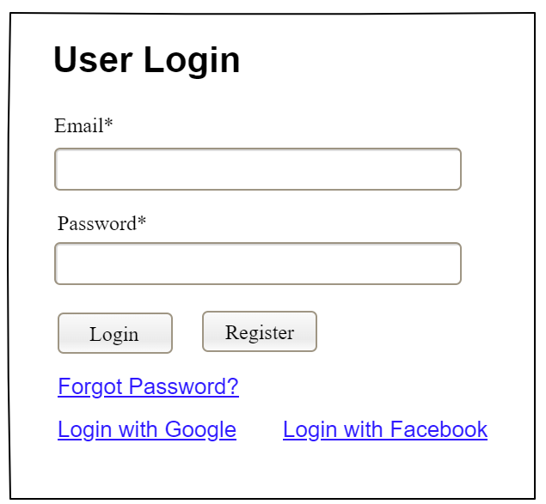

Field Name | Field Type | Description
Email* | Text Box | This is for user to input valid email address for logging in
Password* | Password Box | This is for user to input password for logging in
Login | Button | User clicks to authenticate him/herself into the system with provided email & password
Register | Button | User clicks to redirect to the User Register page for registering new user account to access the system
Forgot Password? | Hyperlink | User clicks to redirect to the Password Reset page for resetting his/her forgot password
Login with Google | Hyperlink | Allow user to login with his/her Google account
Login with Facebook | Hyperlink | Allow user to login with his/her Facebook account

Database Access
Table | CRUD | Description
User | R | Verify UserName & Password information
Setting, User | R | Specify the authorizations of the logged-in user

SQL Commands:
1/ Verify UserName & Password information
SELECT user_id, full_name, email, image_url, status
FROM user WHERE user_name = ? AND password = ?

2/ Specify the authorizations of the logged-in user
SELECT mapped_values FROM setting WHERE setting_id = ?
SELECT setting_name, mapped_values FROM setting WHERE setting_id IN (?)

b. Setting List

UI Design
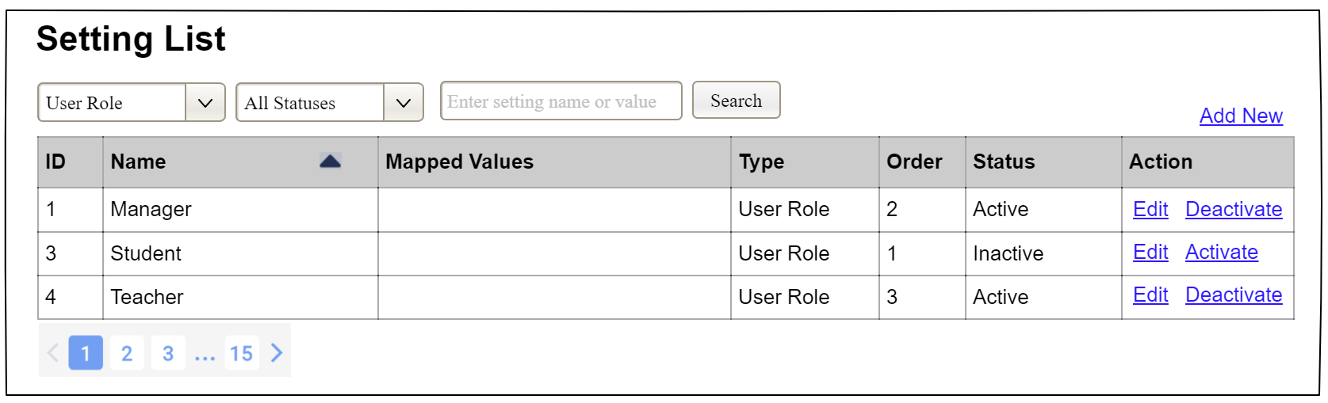

Field Name | Field Type | Description
Search Fields
Setting Type | Combo Box  Single-Choice | Filled with the list of current active setting types  Allow to filter the list by setting type;  Default value is “All Types”
Setting Status | Combo Box  Single-Choice | Values: All Statuses (default), Active, and Inactive  Allow to filter the list by status  Default value: “All Statuses”
Search Phase | Text Box  String (30) | Allow to search using the name or map values  Default value: blank
Search | Button | Click to refresh the list with the defined filter(s) and search phrase.
Add New | Hyperlink | Click to open the Setting Details page for adding new setting (master data)
Data Table
ID | Integer | Auto-increased identifier of the setting
Name | Text | Name of the setting
Mapped Values | Text | Supplementary information for the setting
Type | Text | Type of the setting
Order | Integer | Display order of the setting: the order of the setting type, displayed among the list of settings with the same type
Data Actions
Edit | icon | Click to open the Setting Details page for updating the relevant setting (master data)
Activate | icon | Shown when the data status is inactive. This is to activate the relevant setting (master data)
Deactivate | Ion | Shown when the data status is active. This is to deactivate the relevant setting (master data)

Database Access
Table | CRUD | Description
Setting | RU | Query the list of current settings from the database  Update status of a specific setting

SQL Commands:
1/ Query the list of current settings from the database
SELECT setting_id, setting_name, mapped_values, type_id, display_order, status
FROM setting WHERE (setting_type = ?) AND (status = ?) AND (setting_name LIKE ?)

2/ Update status of a specific setting
UPDATE setting SET status = ? WHERE setting_id = ?

c. Setting Details

UI Design
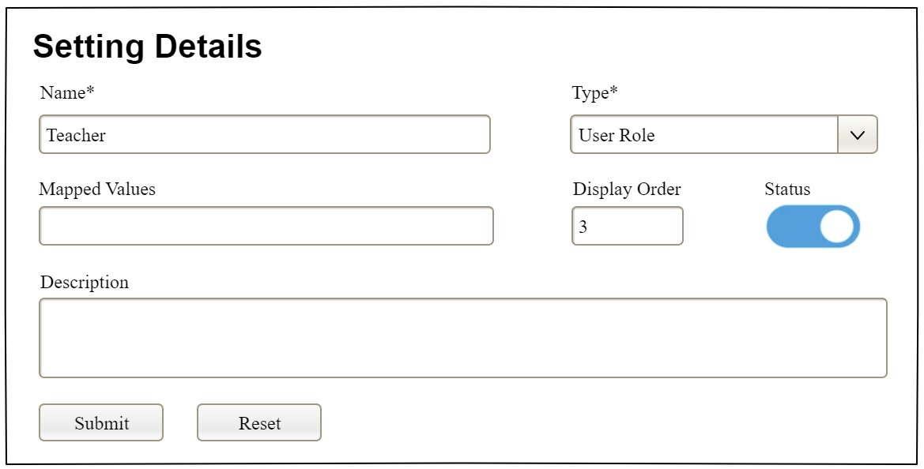

Field Name | Field Type | Description
Name* | Text Box  String (20) | Name of the setting
Type* | Combo Box  (Single Choice) | Type of the setting, filled with the list of setting types  Default value: the first type in the list
Mapped Values | Text Box  String (50) | Supplementary information for the setting (if any)
Order | Text Box  Integer (>=0) | Display order of the setting: the order of the setting type, displayed among the list of settings with the same type
Status | On/Off button | Status of the setting: Active or Inactive  Default value: Active
Description | Text Area  String (200) | Description of the setting
Submit | Button | Click to store new or updated setting details
Reset | Button | Click to reset the changes use has made on the screen fields back to the initial values when the screen is loaded

Database Access
…

IV. Appendix

1. Assumptions & Dependencies
<<Sample:
AS-1: Systems with appropriate user interfaces will be available for cafeteria employees to process the expected volume of meals ordered.
AS-2: Cafeteria staff and vehicles will be available to deliver all meals for specified delivery time slots within 15 minutes of the requested delivery time.
DE-1: If a restaurant has its own on-line ordering system, the Cafeteria Ordering System must be able to communicate with it bi-directionally.
>>

2. Limitations & Exclusions

3. Business Rules
<<Sample
ID | Category | Rule Definition
BR-01 | Constraints | Delivery time windows are 15 minutes, beginning on each quarter hour.
BR-02 | Constraints | Deliveries must be completed between 10:00 A.M. and 2:00 P.M. local time, inclusive.
BR-03 | Facts | All meals in a single order must be delivered to the same location.
BR-04 | Facts | All meals in a single order must be paid for by using the same payment method.
BR-11 | Constraints | If an order is to be delivered, the patron must pay by payroll deduction.
BR-12 | Computations | Order price is calculated as the sum of each food item price times the quantity of that food item ordered, plus applicable sales tax, plus a delivery charge if a meal is delivered outside the free delivery zone.
>>

4. ..

